Chapter 9
Application: International Trade
Multiple Choice
1. An important factor in the decline of the U.S. textile industry over the past 100 or so years is
a. foreign competitors that could produce quality textile goods at low cost.
b. lower prices of goods that are substitutes for clothing.
c. a decrease in Americans’ demand for clothing, due to increased incomes and the fact that clothing is an inferior good.
d. the fact that the minimum wage in the U.S. has failed to keep pace with the cost of living.
ANS: A PTS: 1 DIF: 1 REF: 9-0
TOP: International trade MSC: Interpretive
2. With which of the Ten Principles of Economics is the study of international trade most closely connected?
a. People face tradeoffs.
b. Trade can make everyone better off.
c. Governments can sometimes improve market outcomes.
d. Prices rise when the government prints too much money.
ANS: B PTS: 1 DIF: 1 REF: 9-0
TOP: International trade MSC: Interpretive
3. A logical starting point from which the study of international trade begins is
a. the recognition that not all markets are competitive.
b. the recognition that government intervention in markets sometimes enhances the economic welfare of the society.
c. the principle of absolute advantage.
d. the principle of comparative advantage.
ANS: D PTS: 1 DIF: 1 REF: 9-0
TOP: International trade | Comparative advantage MSC: Interpretive
4. A tax on an imported good is called a
a. quota.
b. tariff.
c. supply tax.
d. trade tax.
ANS: B PTS: 1 DIF: 1 REF: 9-1
TOP: Tariffs MSC: Definitional
5. The price of a good that prevails in a world market is called the
a. absolute price.
b. relative price.
c. comparative price.
d. world price.
ANS: D PTS: 1 DIF: 1 REF: 9-1
TOP: Price | World trade MSC: Definitional
6. The price of cotton that prevails in international markets is called the
a. export price of cotton.
b. import price of cotton.
c. comparative-advantage price of cotton.
d. world price of cotton.
ANS: D PTS: 1 DIF: 1 REF: 9-1
TOP: International trade | Prices MSC: Definitional
7. If a country allows trade and, for a certain good, the domestic price without trade is higher than the world price,
a. the country will be an exporter of the good.
b. the country will be an importer of the good.
c. the country will be neither an exporter nor an importer of the good.
d. Additional information is needed about demand to determine whether the country will be an exporter of the good, an importer of the good, or neither.
ANS: B PTS: 1 DIF: 2 REF: 9-1
TOP: Prices | Imports MSC: Interpretive
8. If a country allows trade and, for a certain good, the domestic price without trade is lower than the world price,
a. the country will be an exporter of the good.
b. the country will be an importer of the good.
c. the country will be neither an exporter nor an importer of the good.
d. Additional information is needed about demand to determine whether the country will be an exporter of the good, an importer of the good, or neither.
ANS: A PTS: 1 DIF: 2 REF: 9-1
TOP: Prices | Exports MSC: Interpretive
9. For any country, if the world price of computers is higher than the domestic price of computers without trade, that country should
a. export computers, since that country has a comparative advantage in computers.
b. import computers, since that country has a comparative advantage in computers.
c. neither export nor import computers, since that country cannot gain from trade.
d. neither export nor import computers, since that country already produces computers at a low cost compared to other countries.
ANS: A PTS: 1 DIF: 2 REF: 9-1
TOP: Exports | Comparative advantage MSC: Applicative
10. If the world price of textiles is higher than Vietnam’s domestic price of textiles without trade, then Vietnam
a. should import textiles.
b. has a comparative advantage in textiles.
c. should produce just enough textiles to meet its domestic demand.
d. should refrain altogether from producing textiles.
ANS: B PTS: 1 DIF: 2 REF: 9-1
TOP: Price | Comparative advantage MSC: Interpretive
11. Assume, for Canada, that the domestic price of steel without international trade is higher than the world price of steel. This suggests that, in the production of steel,
a. Canada has a comparative advantage over other countries and Canada will import steel.
b. Canada has a comparative advantage over other countries and Canada will export steel.
c. other countries have a comparative advantage over Canada and Canada will import steel.
d. other countries have a comparative advantage over Canada and Canada will export steel.
ANS: C PTS: 1 DIF: 2 REF: 9-1
TOP: Comparative advantage | Prices MSC: Applicative
12. Assume, for the U.S., that the domestic price of beef without international trade is lower than the world price of beef. This suggests that, in the production of beef,
a. the U.S. has a comparative advantage over other countries and the U.S. will export beef.
b. the U.S. has a comparative advantage over other countries and the U.S. will import beef.
c. other countries have a comparative advantage over the U.S. and the U.S. will export beef.
d. other countries have a comparative advantage over the U.S. and the U.S. will import beef.
ANS: A PTS: 1 DIF: 2 REF: 9-1
TOP: Comparative advantage | Prices MSC: Applicative
13. Suppose the United States exports cars to France and imports cheese from Switzerland. This situation suggests that
a. the United States has a comparative advantage relative to Switzerland in producing cheese, and France has a comparative advantage relative to the United States in producing cars.
b. the United States has a comparative advantage relative to France in producing cars, and Switzerland has a comparative advantage relative to the United States in producing cheese.
c. the United States has an absolute advantage relative to Switzerland in producing cheese, and France has an absolute advantage relative to the United States in producing cars.
d. the United States has an absolute advantage relative to France in producing cars, and Switzerland has an absolute advantage relative to the United States in producing cheese.
ANS: B PTS: 1 DIF: 2 REF: 9-1
TOP: Comparative advantage MSC: Interpretive
14. Trade among nations is ultimately based on
a. absolute advantage.
b. strategic advantage.
c. comparative advantage.
d. technical advantage.
ANS: C PTS: 1 DIF: 1 REF: 9-1
TOP: Trade | Comparative advantage MSC: Interpretive
15. A country has a comparative advantage in a product if the world price is
a. lower than that country’s domestic price without trade.
b. higher than that country’s domestic price without trade.
c. equal to that country’s domestic price without trade.
d. not subject to manipulation by organizations that govern international trade.
ANS: B PTS: 1 DIF: 2 REF: 9-1
TOP: Price | Comparative advantage MSC: Interpretive
16. Suppose Haiti has a comparative advantage over other countries in producing sugar, but other countries have an absolute advantage over Haiti in producing sugar. If trade in sugar is allowed, Haiti
a. will import sugar.
b. will export sugar.
c. will either export sugar or export sugar, but it is not clear from the given information.
d. would have nothing to gain either from exporting or importing sugar.
ANS: B PTS: 1 DIF: 2 REF: 9-1
TOP: Comparative advantage | Absolute advantage MSC: Interpretive
17. When, in our analysis of the gains and losses of international trade, we assume that a country is small, we are in effect assuming that the country
a. cannot experience significant gains or losses by trading with other countries.
b. cannot have a significant comparative advantage over other countries.
c. cannot affect world prices by trading with other countries.
d. All of the above are correct.
ANS: C PTS: 1 DIF: 2 REF: 9-2
TOP: Prices | International trade MSC: Interpretive
18. When, in our analysis of the gains and losses from international trade, we assume that a particular country is small, we are
a. assuming the domestic price before trade will continue to prevail once that country is opened up to trade with other countries.
b. assuming there is no demand for that country’s domestically-produced goods by other countries.
c. assuming international trade can benefit producers, but not consumers, in that country.
d. making an assumption that is not necessary to analyze the gains and losses from international trade.
ANS: D PTS: 1 DIF: 2 REF: 9-2
TOP: Assumptions | International trade MSC: Interpretive
19. In analyzing the gains and losses from international trade, to say that Moldova is a small country is to say that
a. Moldova can only import goods; it cannot export goods.
b. Moldova’s choice of which goods to export and which goods to import is not based on the principle of comparative advantage.
c. only the domestic price of a good is relevant for Moldova; the world price of a good is irrelevant.
d. Moldova is a price taker.
ANS: D PTS: 1 DIF: 2 REF: 9-2
TOP: Prices | International trade MSC: Interpretive
20. When a country allows trade and becomes an exporter of a good,
a. domestic producers gain and domestic consumers lose.
b. domestic producers lose and domestic consumers gain.
c. domestic producers and domestic consumers both gain.
d. domestic producers and domestic consumers both lose.
ANS: A PTS: 1 DIF: 2 REF: 9-2
TOP: Exports | Gains from trade MSC: Interpretive
21. When a country allows trade and becomes an importer of a good,
a. both domestic producers and domestic consumers become better off.
b. domestic producers become better off, and domestic consumers become worse off.
c. domestic producers become worse off, and domestic consumers become better off.
d. both domestic producers and domestic consumers become worse off.
ANS: C PTS: 1 DIF: 2 REF: 9-2
TOP: Imports | Gains from trade MSC: Interpretive
22. When a country allows trade and becomes an importer of a good,
a. everyone in the country benefits.
b. the gains of the winners exceed the losses of the losers.
c. the losses of the losers exceed the gains of the winners.
d. everyone in the country loses.
ANS: B PTS: 1 DIF: 2 REF: 9-2
TOP: Imports | Gains from trade MSC: Interpretive
23. When the nation of Econoland allows trade and becomes an exporter of televisions,
a. residents of Econoland who produce televisions become worse off; residents of Econoland who buy televisions become better off; and the economic well-being of Econoland rises.
b. residents of Econoland who produce televisions become worse off; residents of Econoland who buy televisions become better off; and the economic well-being of Econoland falls.
c. residents of Econoland who produce televisions become better off; residents of Econoland who buy televisions become worse off; and the economic well-being of Econoland rises.
d. residents of Econoland who produce televisions become better off; residents of Econoland who buy televisions become worse off; and the economic well-being of Econoland falls.
ANS: C PTS: 1 DIF: 2 REF: 9-2
TOP: Exports | Economic welfare MSC: Applicative
24. When the nation of Duxembourg allows trade and becomes an importer of software,
a. residents of Duxembourg who produce software become worse off; residents of Duxembourg who buy software become better off; and the economic well-being of Duxembourg rises.
b. residents of Duxembourg who produce software become worse off; residents of Duxembourg who buy software become better off; and the economic well-being of Duxembourg falls.
c. residents of Duxembourg who produce software become better off; residents of Duxembourg who buy software become worse off; and the economic well-being of Duxembourg rises.
d. residents of Duxembourg who produce software become better off; residents of Duxembourg who buy software become worse off; and the economic well-being of Duxembourg falls.
ANS: A PTS: 1 DIF: 2 REF: 9-2
TOP: Imports | Economic welfare MSC: Applicative
25. When a nation first begins to trade with other countries and the nation becomes an exporter of corn,
a. this is an indication that the world price of corn exceeds the nation’s domestic price of corn in the absence of trade.
b. this is an indication that the nation has a comparative advantage in producing corn.
c. the nation’s consumers of corn become worse off and the nation’s producers of corn become better off.
d. All of the above are correct.
ANS: D PTS: 1 DIF: 3 REF: 9-2
TOP: Exports | Comparative advantage | Economic welfare MSC: Applicative
26. When a nation first begins to trade with other countries and the nation becomes an importer of soybeans,
a. this is an indication that the world price of soybeans exceeds the nation’s domestic price of soybeans in the absence of trade.
b. this is an indication that the nation has a comparative advantage in producing soybeans.
c. the nation’s producers of soybeans become worse off and the nation’s consumers of soybeans become better off.
d. All of the above are correct.
ANS: C PTS: 1 DIF: 3 REF: 9-2
TOP: Imports | Comparative advantage | Economic welfare MSC: Applicative
27. Trade raises the economic well-being of a nation in the sense that
a. the gains of the winners exceed the losses of the losers.
b. everyone in an economy gains from trade.
c. since countries can choose what products to trade, they will pick those products that are most beneficial to society.
d. the nation joins the international community when it begins to engage in trade.
ANS: A PTS: 1 DIF: 2 REF: 9-2
TOP: Trade | Economic welfare MSC: Interpretive
28. When a country allows trade and becomes an exporter of a good,
a. the gains of the domestic producers of the good exceed the losses of the domestic consumers of the good.
b. the gains of the domestic consumers of the good exceed the losses of the domestic producers of the good.
c. the losses of the domestic producers of the good exceed the gains of the domestic consumers of the good.
d. the losses of the domestic consumers of the good exceed the gains of the domestic producers of the good.
ANS: A PTS: 1 DIF: 3 REF: 9-2
TOP: Exports | Economic welfare MSC: Applicative
29. When a country allows trade and becomes an importer of steel,
a. the losses of the domestic producers of steel exceed the gains of the domestic consumers of steel.
b. the losses of the domestic consumers of steel exceed the gains of the domestic producers of steel.
c. the gains of the domestic producers of steel exceed the losses of the domestic consumers of steel.
d. the gains of the domestic consumers of steel exceed the losses of the domestic producers of steel.
ANS: D PTS: 1 DIF: 3 REF: 9-2
TOP: Imports | Economic welfare MSC: Applicative
30. When a country allows trade and becomes an exporter of a good, which of the following is not a consequence?
a. The price paid by domestic consumers of the good increases.
b. The price received by domestic producers of the good increases.
c. The losses of domestic consumers of the good exceed the gains of domestic producers of the good.
d. The gains of domestic producers of the good exceed the losses of domestic consumers of the good.
ANS: C PTS: 1 DIF: 3 REF: 9-2
TOP: Exports | Economic welfare MSC: Applicative
31. When a country allows trade and becomes an importer of bottled water, which of the following is not a consequence?
a. The gains of domestic consumers of bottled water exceed the losses of domestic producers of bottled water.
b. The losses of domestic producers of bottled water exceed the gains of domestic consumers of bottled water.
c. The price paid by domestic consumers of bottled water decreases.
d. The price received by domestic producers of bottled water decreases.
ANS: B PTS: 1 DIF: 3 REF: 9-2
TOP: Imports | Economic welfare MSC: Applicative
32. When a country allows trade and becomes an exporter of a good,
a. consumer surplus and producer surplus both increase.
b. consumer surplus and producer surplus both decrease.
c. consumer surplus increases and producer surplus decreases.
d. consumer surplus decreases and producer surplus increases.
ANS: D PTS: 1 DIF: 2 REF: 9-2
TOP: Exports | Consumer surplus | Producer surplus MSC: Interpretive
33. When a country allows trade and becomes an importer of a good,
a. consumer surplus and producer surplus both increase.
b. consumer surplus and producer surplus both decrease.
c. consumer surplus increases and producer surplus decreases.
d. consumer surplus decreases and producer surplus increases.
ANS: C PTS: 1 DIF: 2 REF: 9-2
TOP: Imports | Consumer surplus | Producer surplus MSC: Interpretive
34. Which of the following statements is true?
a. Free trade benefits a country when it exports but harms it when it imports.
b. "Voluntary" limits on Canadian exports of hogs are better for the United States than U.S. tariffs placed on Canadian hog exports.
c. Tariffs and quotas differ in that tariffs work like a tax and therefore impose deadweight losses, whereas quotas do not impose deadweight losses.
d. Free trade benefits a country both when it exports and when it imports.
ANS: D PTS: 1 DIF: 2 REF: 9-2
TOP: Trade policy MSC: Applicative
35. When a country allows international trade and becomes an exporter of a good,
a. domestic producers of the good become better off.
b. domestic consumers of the good become worse off.
c. the gains of the winners exceed the losses of the losers.
d. All of the above are correct.
ANS: D PTS: 1 DIF: 2 REF: 9-2
TOP: Exports | Economic Welfare MSC: Applicative
36. Suppose Scotland goes from being an isolated country to being an exporter of wool. As a result,
a. consumer surplus of Scottish consumers of wool increases.
b. producer surplus of Scottish producers of wool increases.
c. total surplus of Scottish wool consumers and producers remains constant.
d. it is reasonable to infer that other countries have a comparative advantage over Scotland in wool production.
ANS: B PTS: 1 DIF: 2 REF: 9-2
TOP: Exports | Economic Welfare MSC: Applicative
37. When a country allows international trade and becomes an importer of a good,
a. domestic producers of the good become better off.
b. domestic consumers of the good become worse off.
c. the gains of the winners exceed the losses of the losers.
d. All of the above are correct.
ANS: C PTS: 1 DIF: 2 REF: 9-2
TOP: Imports | Economic Welfare MSC: Applicative
38. Assume, for France, that the domestic price of tea without international trade is higher than the world price of tea. This suggests that
a. other countries have a comparative advantage over France in producing tea.
b. France has an absolute advantage over other countries in producing tea.
c. France will export tea if international trade is allowed.
d. French tea buyers will become worse off if international trade is allowed.
ANS: A PTS: 1 DIF: 2 REF: 9-2
TOP: Comparative advantage | Prices MSC: Applicative
39. Suppose a country begins to allow international trade in steel. Which of the following outcomes will be observed regardless of whether the country finds itself importing steel or exporting steel?
a. The sum of consumer surplus and producer surplus for domestic traders of steel increases.
b. The quantity of steel demanded by domestic consumers increases.
c. Domestic producers of steel receive a higher price for steel.
d. The losses of the losers exceed the gains of the winners.
ANS: A PTS: 1 DIF: 2 REF: 9-2
TOP: Trade | Economic Welfare MSC: Applicative
40. After a country goes from disallowing trade in sugar with other countries to allowing trade in sugar with other countries,
a. the domestic price of sugar will be greater than the world price of sugar.
b. the domestic price of sugar will be lower than the world price of sugar.
c. the domestic price of sugar will equal the world price of sugar.
d. The world price of sugar does not matter; the domestic price of sugar prevails.
ANS: C PTS: 1 DIF: 2 REF: 9-2
TOP: Trade | Prices MSC: Interpretive
41. Within a country, the domestic price of a product will equal the world price if
a. trade restrictions are imposed on the product.
b. the country allows free trade.
c. the country chooses to import, but not export, the product.
d. the country chooses to export, but not import, the product.
ANS: B PTS: 1 DIF: 2 REF: 9-2
TOP: International trade | Prices MSC: Interpretive
42. For any country that allows free trade,
a. domestic quantity demanded is equal to domestic quantity supplied at the world price.
b. domestic quantity demanded is greater than domestic quantity supplied at the world price.
c. both producers and consumers in that country gain when domestic products are exported, but both groups lose when foreign products are imported.
d. the domestic price is equal to the world price.
ANS: D PTS: 1 DIF: 2 REF: 9-2
TOP: International trade | Prices MSC: Interpretive
43. The world price of a simple electronic calculator is $5.00. Before Singapore allowed trade in calculators, the price of a calculator there was $4.00. Once Singapore began allowing trade in calculators with other countries,Singapore began
a. importing calculators and the price of a calculator in Singapore increased to $5.00.
b. importing calculators and the price of a calculator in Singapore remained at $4.00.
c. exporting calculators and the price of a calculator in Singapore increased to $5.00.
d. exporting calculators and the price of a calculator in Singapore remained at $4.00.
ANS: C PTS: 1 DIF: 2 REF: 9-2
TOP: Exports | Prices MSC: Applicative
44. The world price of a pound of T-bone steak is $9.00. Before Guatemala allowed trade in beef, the price of a pound of T-bone steak there was $12.00. Once Guatemala began allowing trade in beef with other countries, Guatemala began
a. exporting T-bone steak and the price per pound in Guatemala remained at $12.00.
b. exporting T-bone steak and the price per pound in Guatemala decreased to $9.00.
c. importing T-bone steak and the price per pound in Guatemala remained at $12.00.
d. importing T-bone steak and the price per pound in Guatemala decreased to $9.00.
ANS: D PTS: 1 DIF: 2 REF: 9-2
TOP: Imports | Prices MSC: Applicative
45. Suppose a country abandons a no-trade policy in favor of a free-trade policy. If, as a result, the domestic price of beans increases to equal the world price of beans, then
a. that country becomes an exporter of beans.
b. that country has a comparative advantage in producing beans.
c. at the world price, the quantity of beans supplied in that country exceeds the quantity of beans demanded in that country.
d. All of the above are correct.
ANS: D PTS: 1 DIF: 2 REF: 9-2
TOP: Exports | Comparative advantage MSC: Applicative
46. Suppose a country abandons a no-trade policy in favor of a free-trade policy. If, as a result, the domestic price of pistachios decreases to equal the world price of pistachios, then
a. that country becomes an importer of pistachios.
b. that country has a comparative advantage in producing pistachios.
c. at the world price, the quantity of pistachios supplied in that country exceeds the quantity of pistachios demanded in that country.
d. All of the above are correct.
ANS: A PTS: 1 DIF: 2 REF: 9-2
TOP: Imports | Comparative advantage MSC: Applicative
Figure 9-1
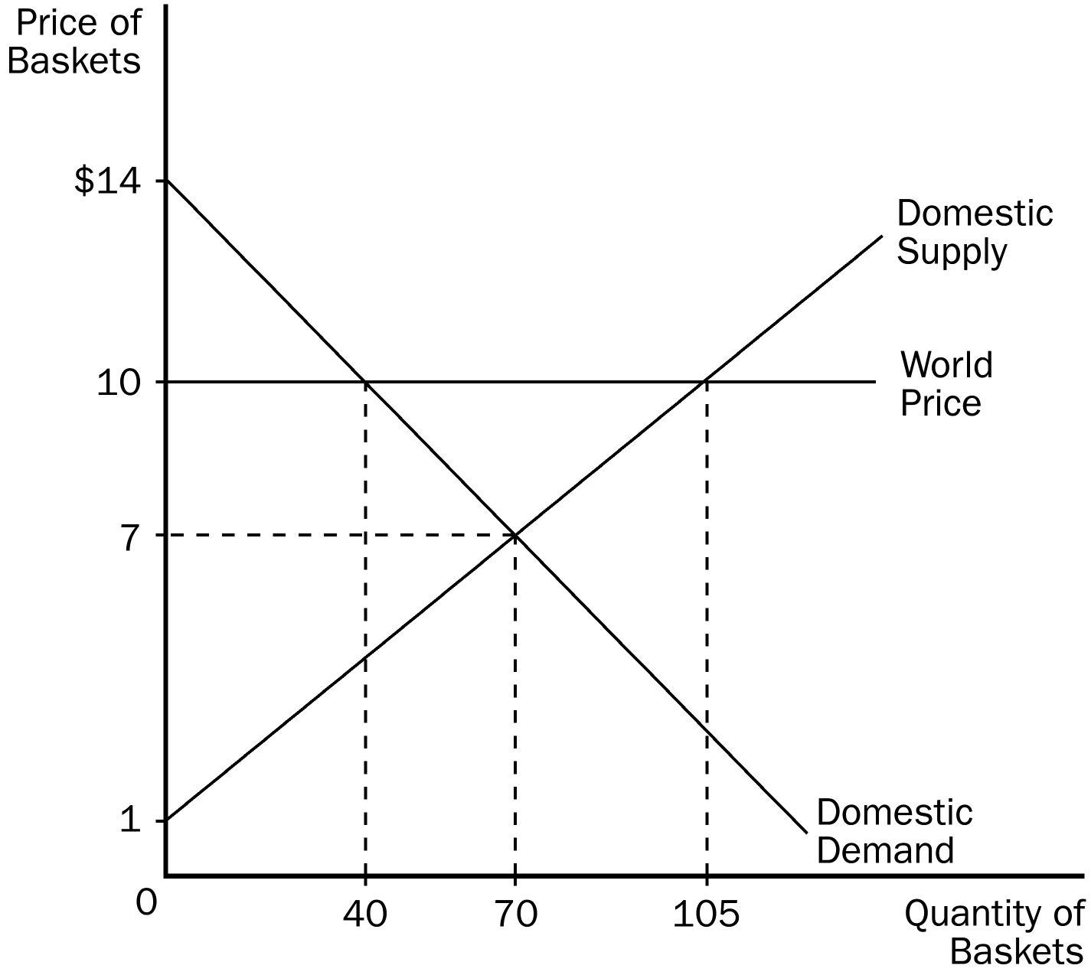
47. Refer to Figure 9-1. Without trade, consumer surplus is
a. $210.
b. $245.
c. $455.
d. $490.
ANS: B PTS: 1 DIF: 2 REF: 9-2
TOP: Consumer surplus MSC: Applicative
48. Refer to Figure 9-1. Without trade, producer surplus is
a. $210.
b. $245.
c. $455.
d. $490.
ANS: A PTS: 1 DIF: 2 REF: 9-2
TOP: Producer surplus MSC: Applicative
49. Refer to Figure 9-1. With free trade, this country will
a. import 40 baskets.
b. import 70 baskets.
c. export 35 baskets.
d. export 65 baskets.
ANS: D PTS: 1 DIF: 2 REF: 9-2
TOP: Exports MSC: Applicative
50. Refer to Figure 9-1. If this country chooses to trade, the price of baskets in this country will be
a. $10 and 40 baskets will be sold domestically.
b. $10 and 105 baskets will be domestically.
c. $7 and 70 baskets will be sold domestically.
d. $7 and 40 baskets will be sold domestically.
ANS: A PTS: 1 DIF: 2 REF: 9-2
TOP: Price | Quantity demanded MSC: Applicative
51. Refer to Figure 9-1. With free trade, consumer surplus is
a. $45.
b. $80.
c. $210.
d. $245.
ANS: B PTS: 1 DIF: 2 REF: 9-2
TOP: Trade | Consumer surplus MSC: Applicative
52. Refer to Figure 9-1. With free trade, producer surplus is
a. $80.00.
b. $210.00.
c. $245.50.
d. $472.50.
ANS: D PTS: 1 DIF: 2 REF: 9-2
TOP: Trade | Producer surplus MSC: Applicative
53. Refer to Figure 9-1. As a result of trade, total surplus increases by
a. $80.
b. $97.50.
c. $162.50.
d. $495.50.
ANS: B PTS: 1 DIF: 3 REF: 9-2
TOP: Trade | Total surplus MSC: Applicative
54. Refer to Figure 9-1. This country
a. has a comparative advantage in baskets.
b. should export baskets.
c. is a price taker in the world economy.
d. All of the above are correct.
ANS: D PTS: 1 DIF: 2 REF: 9-2
TOP: Exports | Comparative advantage MSC: Applicative
55. Refer to Figure 9-1. The world price for baskets represents
a. the demand for baskets from the rest of the world.
b. the supply of baskets from the rest of the world.
c. the level of inefficiency in the domestic market caused by trade.
d. the gap between domestic quantity demanded and domestic quantity supplied and the resulting shortage.
ANS: A PTS: 1 DIF: 2 REF: 9-2
TOP: International trade | Price MSC: Interpretive
56. Refer to Figure 9-1. At the world price and with free trade,
a. the domestic quantity of baskets demanded is greater than the domestic quantity of baskets supplied.
b. the basket market is in equilibrium.
c. the domestic demand for baskets is perfectly inelastic.
d. both domestic producers of baskets and domestic consumers of baskets are better off than they were without free trade.
ANS: B PTS: 1 DIF: 2 REF: 9-2
TOP: Trade | Equilibrium MSC: Interpretive
Figure 9-2. The domestic country is China.
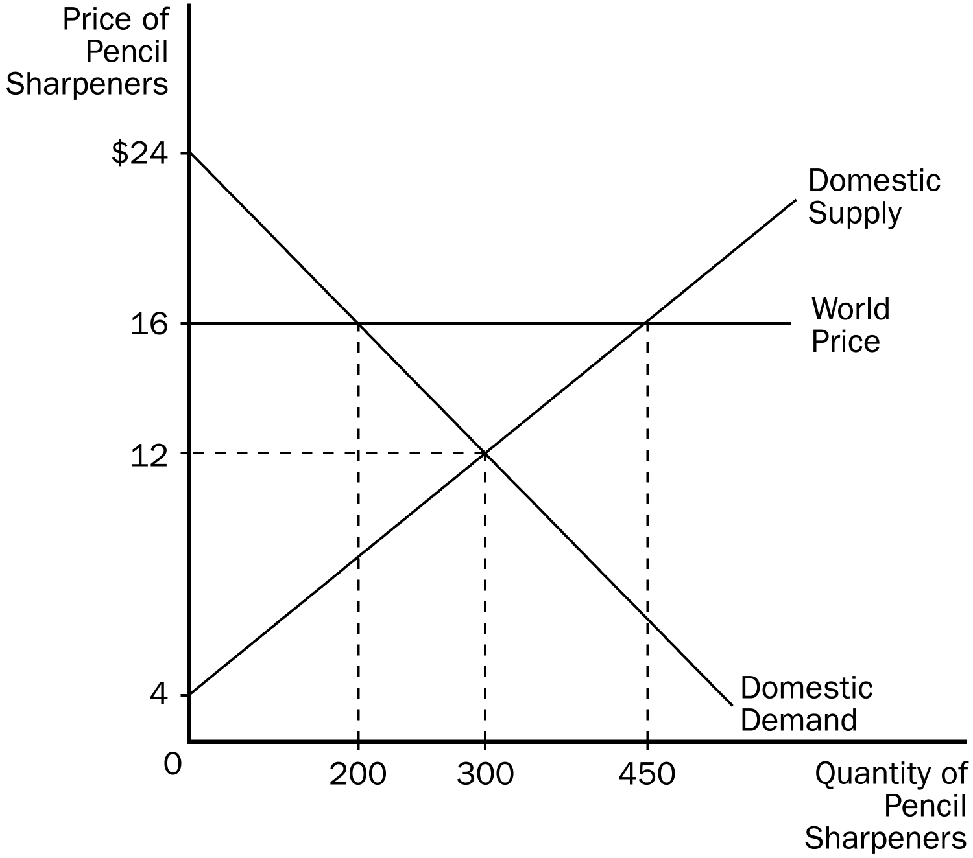
57. Refer to Figure 9-2. With no international trade,
a. the equilibrium price is $12 and the equilibrium quantity is 300.
b. the equilibrium price is $16 and the equilibrium quantity is 200.
c. the equilibrium price is $16 and the equilibrium quantity is 300.
d. the equilibrium price is $16 and the equilibrium quantity is 450.
ANS: A PTS: 1 DIF: 1 REF: 9-2
TOP: Equilibrium price | Equilibrium quantity MSC: Interpretive
58. Refer to Figure 9-2. If China were to abandon a no-trade policy in favor of a free-trade policy,
a. Chinese producers of pencil sharpeners would become worse off.
b. Chinese consumers of pencil sharpeners would become better off.
c. total surplus in the Chinese economy would increase.
d. All of the above are correct.
ANS: C PTS: 1 DIF: 2 REF: 9-2
TOP: Total surplus MSC: Interpretive
59. Refer to Figure 9-2. With trade, China will
a. import 100 pencil sharpeners.
b. import 250 pencil sharpeners.
c. export 150 pencil sharpeners.
d. export 250 pencil sharpeners.
ANS: D PTS: 1 DIF: 2 REF: 9-2
TOP: Exports MSC: Applicative
60. Refer to Figure 9-2. With trade, producer surplus in China is
a. $800.
b. $1,200.
c. $1,800.
d. $2,700.
ANS: D PTS: 1 DIF: 2 REF: 9-2
TOP: Trade | Producer surplus MSC: Applicative
61. Refer to Figure 9-2. Relative to a no-trade situation, which of the following comes with trade?
a. Consumer surplus increases by $1,800 and producer surplus increases by $1,600.
b. Consumer surplus decreases by $1,000 and producer surplus increases by $1,500.
c. Consumer surplus decreases by $1,000 and producer surplus increases by $1,750.
d. Total surplus increases by $400.
ANS: B PTS: 1 DIF: 3 REF: 9-2
TOP: Trade | Total surplus MSC: Applicative
62. Refer to Figure 9-2. The increase in total surplus in China when trade becomes allowed is
a. $400.
b. $500.
c. $600.
d. $750.
ANS: B PTS: 1 DIF: 2 REF: 9-2
TOP: Trade | Total surplus MSC: Applicative
Figure 9-3. The domestic country is Jamaica.
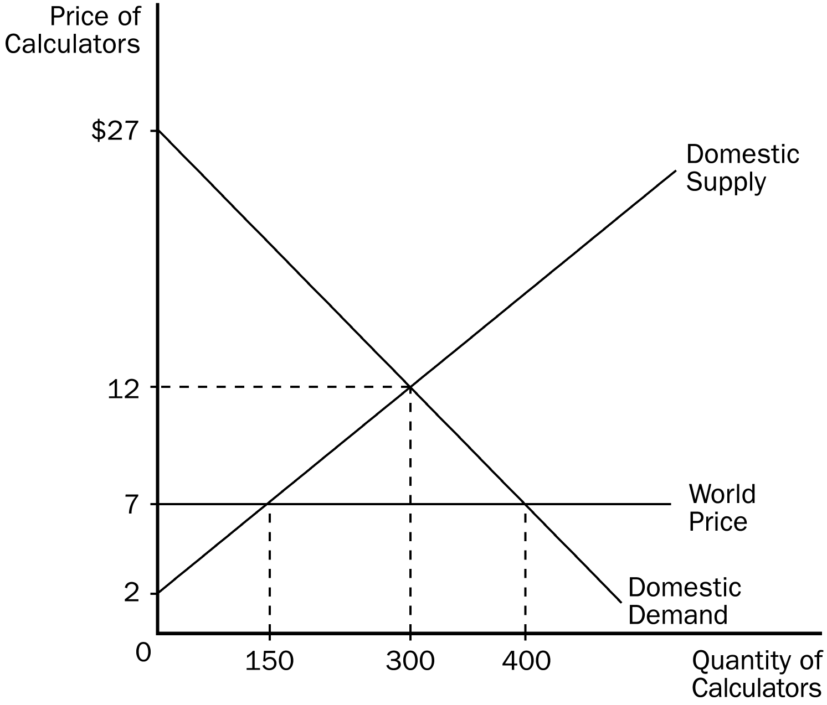
63. Refer to Figure 9-3. With trade, Jamaica
a. imports 150 calculators.
b. imports 250 calculators.
c. exports 100 calculators.
d. exports 250 calculators.
ANS: B PTS: 1 DIF: 2 REF: 9-2
TOP: Imports MSC: Applicative
64. Refer to Figure 9-3. Consumer surplus in Jamaica without trade is
a. $375.
b. $2,000.
c. $2,250.
d. $8,700.
ANS: C PTS: 1 DIF: 2 REF: 9-2
TOP: Trade | Consumer surplus MSC: Applicative
65. Refer to Figure 9-3. The change in total surplus in Jamaica because of trade is
a. $625, and this is an increase in total surplus.
b. $750, and this is an increase in total surplus.
c. $625, and this is a decrease in total surplus.
d. $750, and this is a decrease in total surplus.
ANS: A PTS: 1 DIF: 2 REF: 9-2
TOP: Trade | Total surplus MSC: Applicative
66. Refer to Figure 9-3. Which of the following statements is accurate?
a. Consumer surplus with trade is $3,200.
b. Producer surplus with trade is $375.
c. The gains from trade amount to $800.
d. The gains from trade are represented on the graph by the area bounded by the points (0, $12), (300, $12), (300, $7) and (0, $7).
ANS: B PTS: 1 DIF: 3 REF: 9-2
TOP: Gains from trade MSC: Applicative
Scenario 9-1
The before-trade domestic price of tomatoes in the United States is $500 per ton. The world price of tomatoes is $600 per ton. The U.S. is a price-taker in the tomatoes market.
67. Refer to Scenario 9-1. If trade in tomatoes is allowed, the United States
a. will become an importer of tomatoes.
b. will become an exporter of tomatoes.
c. may become either an importer or an exporter of tomatoes, but this cannot be determined.
d. will experience increases in both consumer surplus and producer surplus.
ANS: B PTS: 1 DIF: 2 REF: 9-2
TOP: Exports | Prices MSC: Applicative
68. Refer to Scenario 9-1. If trade in tomatoes is allowed, the price of tomatoes in the United States
a. will increase, and this will cause consumer surplus to decrease.
b. will decrease, and this will cause consumer surplus to increase.
c. will be unaffected, and consumer surplus will be unaffected as well.
d. could increase or decrease or be unaffected; this cannot be determined.
ANS: A PTS: 1 DIF: 2 REF: 9-2
TOP: Trade | Prices | Consumer surplus MSC: Applicative
69. Refer to Scenario 9-1. If trade in tomatoes is allowed, the price of tomatoes in the United States
a. will be greater than the world price.
b. will be equal to the world price.
c. will be less than the world price.
d. could be greater than, equal to, or less than the world price; this cannot be determined.
ANS: B PTS: 1 DIF: 2 REF: 9-2
TOP: Trade | Prices MSC: Interpretive
70. Refer to Scenario 9-1. If trade in tomatoes is allowed, U.S. producers of tomatoes
a. will be better off.
b. will be worse off.
c. will be unaffected.
d. will experience a decrease in their collective producer surplus.
ANS: A PTS: 1 DIF: 2 REF: 9-2
TOP: Producer surplus MSC: Interpretive
71. Refer to Scenario 9-1. If trade in tomatoes is allowed, the
a. price paid by American consumers of tomatoes is unchanged relative to the no-trade situation.
b. total well-being of American producers of tomatoes is diminished relative to the no-trade situation.
c. total well-being of American consumers of tomatoes is enhanced relative to the no-trade situation.
d. total well-being of the United States is enhanced relative to the no-trade situation.
ANS: D PTS: 1 DIF: 2 REF: 9-2
TOP: Trade | Total surplus MSC: Applicative
Figure 9-4
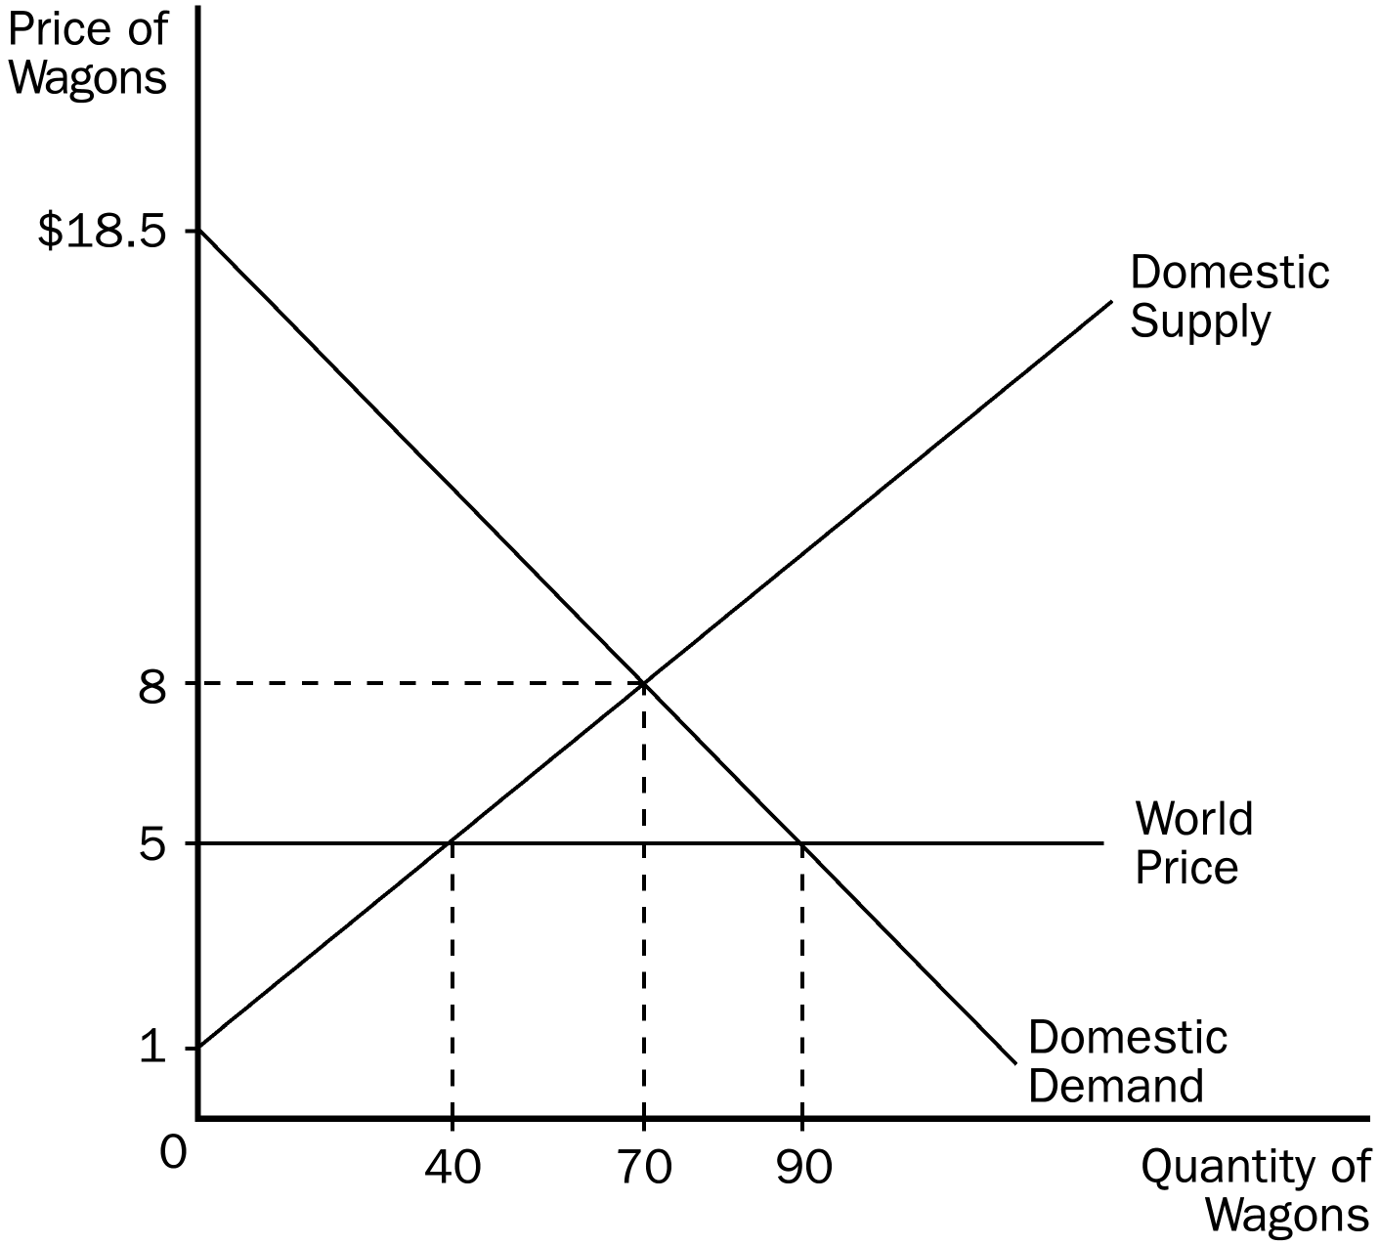
72. Refer to Figure 9-4. The horizontal line at the world price of wagons represents the
a. demand for wagons from the rest of the world.
b. supply of wagons from the rest of the world.
c. level of inefficiency in the domestic market caused by trade.
d. surplus in the domestic wagon market.
ANS: B PTS: 1 DIF: 2 REF: 9-2
TOP: Trade | Prices MSC: Interpretive
73. Refer to Figure 9-4. With trade, this country
a. exports 20 wagons.
b. exports 50 wagons.
c. imports 30 wagons.
d. imports 50 wagons.
ANS: D PTS: 1 DIF: 2 REF: 9-2
TOP: Imports MSC: Applicative
74. Refer to Figure 9-4. Without trade, consumer surplus amounts to
a. $210.50.
b. $245.50.
c. $367.50.
d. $607.50.
ANS: C PTS: 1 DIF: 2 REF: 9-2
TOP: Consumer surplus MSC: Applicative
75. Refer to Figure 9-4. Without trade, producer surplus amounts to
a. $210.
b. $245.
c. $450.
d. $455.
ANS: B PTS: 1 DIF: 2 REF: 9-2
TOP: Producer surplus MSC: Applicative
76. Refer to Figure 9-4. Without trade, total surplus amounts to
a. $122.50.
b. $245.
c. $367.50.
d. $612.50.
ANS: D PTS: 1 DIF: 2 REF: 9-2
TOP: Total surplus MSC: Applicative
77. Refer to Figure 9-4. With trade, the price of wagons in this country is
a. $8, with 70 wagons being produced in this country, 20 of which are exported.
b. $8, with 90 wagons being produced in this country, 50 of which are exported.
c. $5, with 40 wagons being produced in this country and another 30 wagons being imported.
d. $5, with 40 wagons being produced in this country and another 50 wagons being imported.
ANS: D PTS: 1 DIF: 2 REF: 9-2
TOP: Imports | Prices MSC: Applicative
78. Refer to Figure 9-4. With trade, consumer surplus is
a. $245.
b. $362.50.
c. $367.50.
d. $607.50.
ANS: D PTS: 1 DIF: 2 REF: 9-2
TOP: Trade | Consumer surplus MSC: Applicative
79. Refer to Figure 9-4. With trade, producer surplus is
a. $80.
b. $150.
c. $210.
d. $245.
ANS: A PTS: 1 DIF: 2 REF: 9-2
TOP: Trade | Producer surplus MSC: Applicative
80. Refer to Figure 9-4. With trade, total surplus is
a. $245.
b. $367.50.
c. $607.50.
d. $687.50.
ANS: D PTS: 1 DIF: 2 REF: 9-2
TOP: Trade | Total surplus MSC: Applicative
81. Refer to Figure 9-4. Total surplus with trade exceeds total surplus without trade by
a. $60.
b. $75.
c. $135.
d. $210.
ANS: B PTS: 1 DIF: 2 REF: 9-2
TOP: Trade | Total surplus MSC: Applicative
82. Refer to Figure 9-4. The increase in total surplus resulting from trade is
a. $60, since producer surplus increases by $180 and consumer surplus falls by $240.
b. $60, since consumer surplus increases by $180 and producer surplus falls by $240.
c. $75, since consumer surplus increases by $240 and producer surplus falls by $165.
d. $75, since consumer surplus increases by $300 and producer surplus falls by $225.
ANS: C PTS: 1 DIF: 3 REF: 9-2
TOP: Trade | Total surplus MSC: Applicative
83. Refer to Figure 9-4. If this country allows free trade in wagons,
a. consumers will gain and producers will lose.
b. consumers will lose and producers will gain.
c. both consumers and producers will gain.
d. both consumers and producers will lose.
ANS: A PTS: 1 DIF: 2 REF: 9-2
TOP: Trade | Consumer surplus | Producer surplus MSC: Interpretive
84. Refer to Figure 9-4. If this country allows free trade in wagons,
a. consumers will gain more than producers will lose.
b. producers will gain more than consumers will lose.
c. producers and consumers will both gain equally.
d. producers and consumers will both lose equally.
ANS: A PTS: 1 DIF: 2 REF: 9-2
TOP: Economic welfare MSC: Interpretive
85. Refer to Figure 9-4. Bearing in mind that this country is “small,” which of the following events conceivably could cause the country to switch from being an importer of wagons to an exporter of wagons?
a. Incomes of domestic citizens increase, and wagons are a normal good.
b. Within this country, the price of a substitute for wagons decreases.
c. Within this country, the price of a complement to wagons decreases.
d. Wages increase for domestic workers who produce wagons.
ANS: B PTS: 1 DIF: 3 REF: 9-2
TOP: Imports | Exports MSC: Analytical
86. Refer to Figure 9-4. Bearing in mind that this country is “small,” what would happen if there were a decrease in the price of wagon wheels within this country, given that wagons and wagon wheels are complements?
a. The quantity of wagons that this country imports would increase.
b. The quantity of wagons that this country imports would decrease, but the country would still be an importer of wagons.
c. This country would switch from being an importer of wagons to an exporter of wagons.
d. The domestic price without trade would move closer to the world price.
ANS: A PTS: 1 DIF: 3 REF: 9-2
TOP: Imports | Exports MSC: Analytical
Figure 9-5
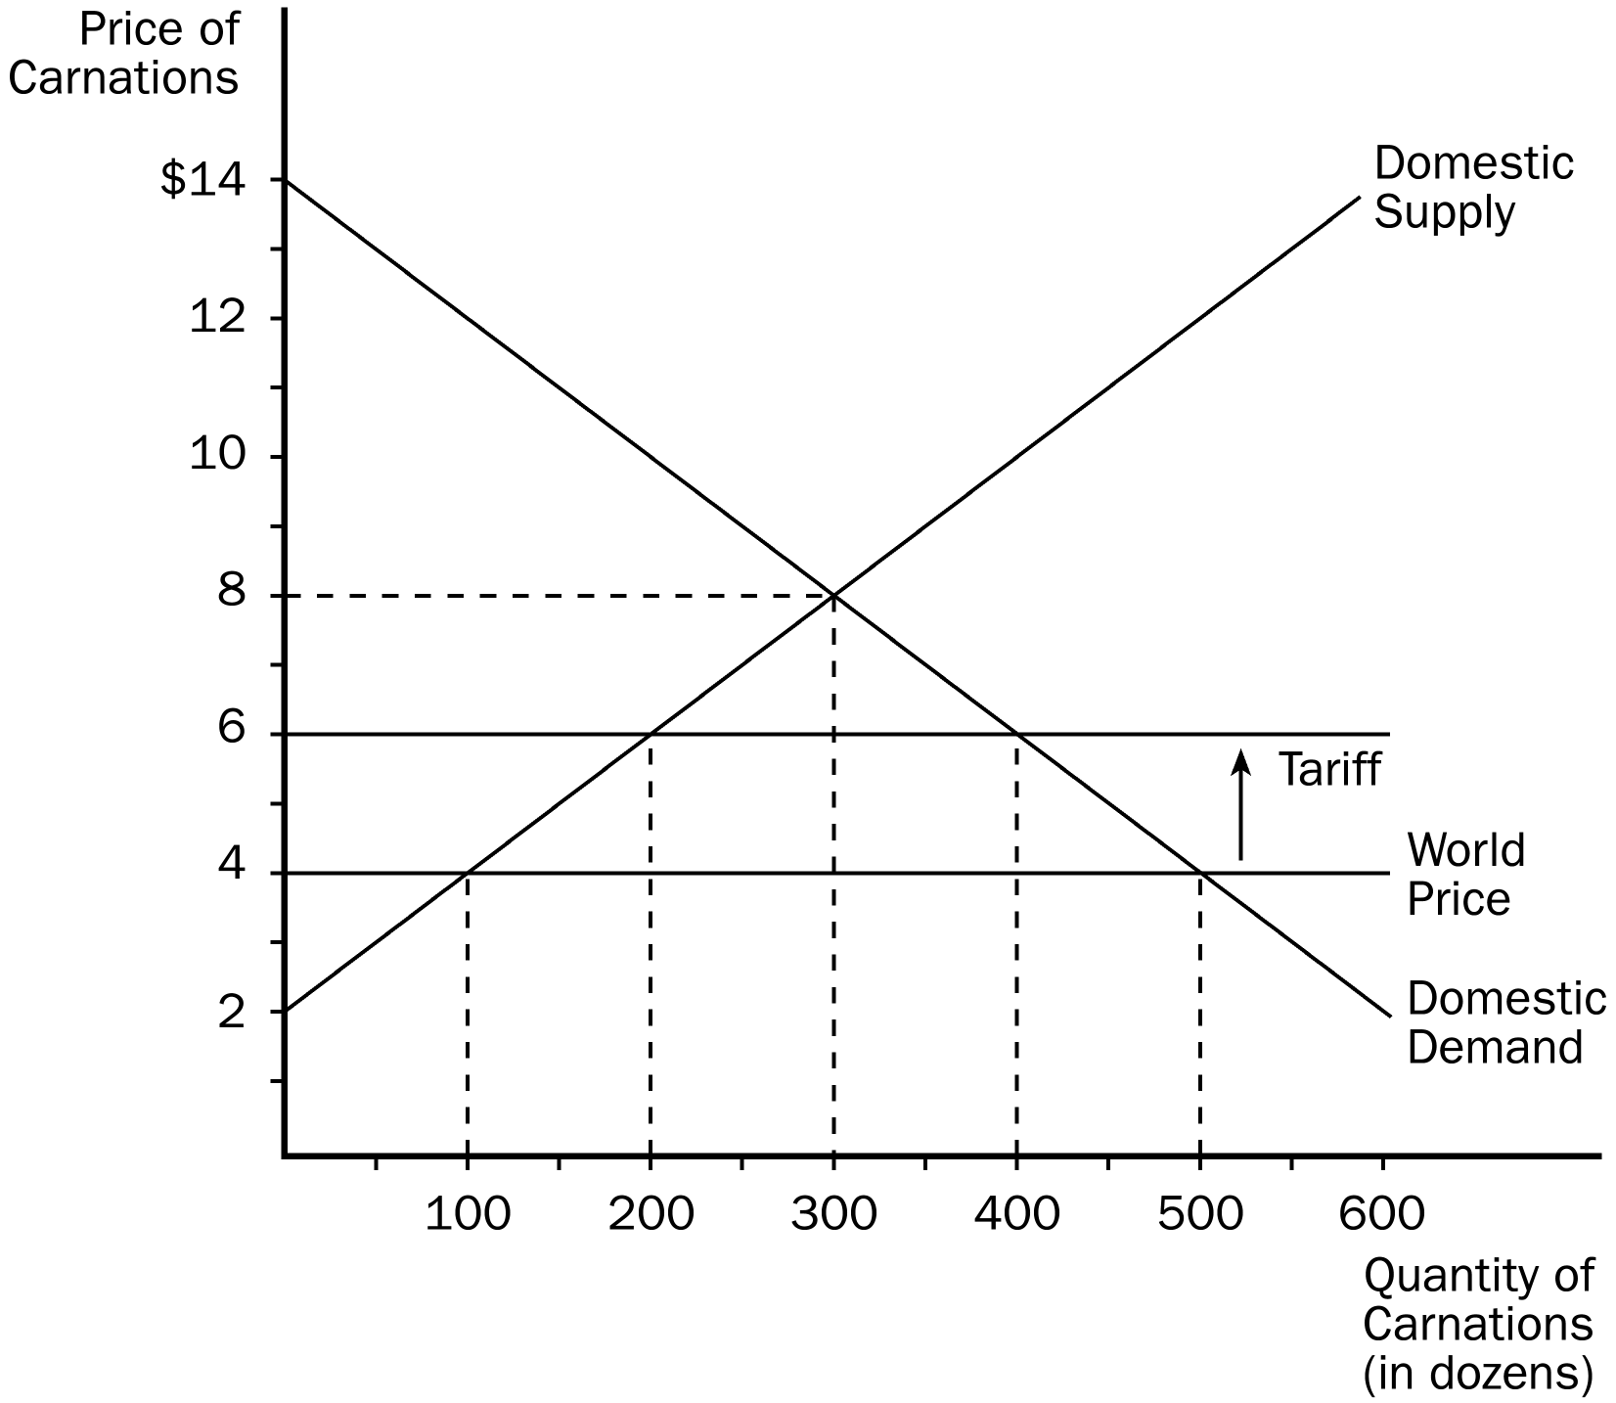
87. Refer to Figure 9-5. Without trade, the equilibrium price of carnations is
a. $8 and the equilibrium quantity is 300.
b. $6 and the equilibrium quantity is 200.
c. $6 and the equilibrium quantity is 400.
d. $4 and the equilibrium quantity is 500.
ANS: A PTS: 1 DIF: 1 REF: 9-2
TOP: Equilibrium price | Equilibrium quantity MSC: Interpretive
88. Refer to Figure 9-5. With trade and without a tariff,
a. the domestic price is equal to the world price.
b. carnations are sold at $8 in this market.
c. there is a shortage of 400 carnations in this market.
d. this country imports 200 carnations.
ANS: A PTS: 1 DIF: 2 REF: 9-2
TOP: Trade | Prices MSC: Interpretive
89. Refer to Figure 9-5. Before the tariff is imposed, this country
a. imports 200 carnations.
b. imports 400 carnations.
c. exports 200 carnations.
d. exports 400 carnations.
ANS: B PTS: 1 DIF: 2 REF: 9-2
TOP: Imports MSC: Applicative
90. Refer to Figure 9-5. The size of the tariff on carnations is
a. $8 per dozen.
b. $6 per dozen.
c. $4 per dozen.
d. $2 per dozen.
ANS: D PTS: 1 DIF: 1 REF: 9-2
TOP: Tariffs MSC: Interpretive
91. Refer to Figure 9-5. The imposition of a tariff on carnations
a. increases the number of carnations imported by 100.
b. increases the number of carnations imported by 200.
c. decreases the number of carnations imported by 200.
d. decreases the number of carnations imported by 400.
ANS: C PTS: 1 DIF: 2 REF: 9-2
TOP: Tariffs | Imports MSC: Applicative
92. Refer to Figure 9-5. The amount of revenue collected by the government from the tariff is
a. $200.
b. $400.
c. $500.
d. $600.
ANS: B PTS: 1 DIF: 2 REF: 9-2
TOP: Tariffs | Government MSC: Applicative
93. Refer to Figure 9-5. When a tariff is imposed in the market, domestic producers
a. gain by $100.
b. gain by $200.
c. gain by $300.
d. lose by $100.
ANS: C PTS: 1 DIF: 2 REF: 9-2
TOP: Tariffs | Producer surplus MSC: Applicative
94. Refer to Figure 9-5. The amount of deadweight loss caused by the tariff equals
a. $100.
b. $200.
c. $400.
d. $500.
ANS: B PTS: 1 DIF: 3 REF: 9-2
TOP: Tariffs | Deadweight losses MSC: Applicative
95. Refer to Figure 9-5. When the tariff is imposed, domestic consumers
a. lose by $500.
b. lose by $900.
c. gain by $500.
d. gain by $900.
ANS: B PTS: 1 DIF: 2 REF: 9-2
TOP: Tariffs | Consumer surplus MSC: Applicative
96. The before-trade price of fish in Greece is $3.00 per pound. The world price of fish is $5.00 per pound. Greece is a price-taker in the fish market. If Greece allows trade in fish, then Greece will become an
a. importer of fish and the price of fish in Greece will be $3.00.
b. importer of fish and the price of fish in Greece will be $5.00.
c. exporter of fish and the price of fish in Greece will be $3.00.
d. exporter of fish and the price of fish in Greece will be $5.00.
ANS: D PTS: 1 DIF: 2 REF: 9-2
TOP: Exports | Prices MSC: Applicative
97. The before-trade price of fish in Greece is $3.00 per pound. The world price of fish is $5.00 per pound. Greece is a price-taker in the fish market. If Greece begins to allow trade in fish, its consumers of fish will become
a. better off, its producers of fish will become better off, and on balance the citizens of Greece will become better off.
b. worse off, its producers of fish will become better off, and on balance the citizens of Greece will become better off.
c. worse off, its producers of fish will become better off, and on balance the citizens of Greece will become worse off.
d. better off, its producers of fish will become worse off, and on balance the citizens of Greece will become worse off.
ANS: B PTS: 1 DIF: 3 REF: 9-2
TOP: Exports | Prices | Economic welfare MSC: Applicative
Figure 9-6. The figure applies to the nation of Wales and the good is cheese.
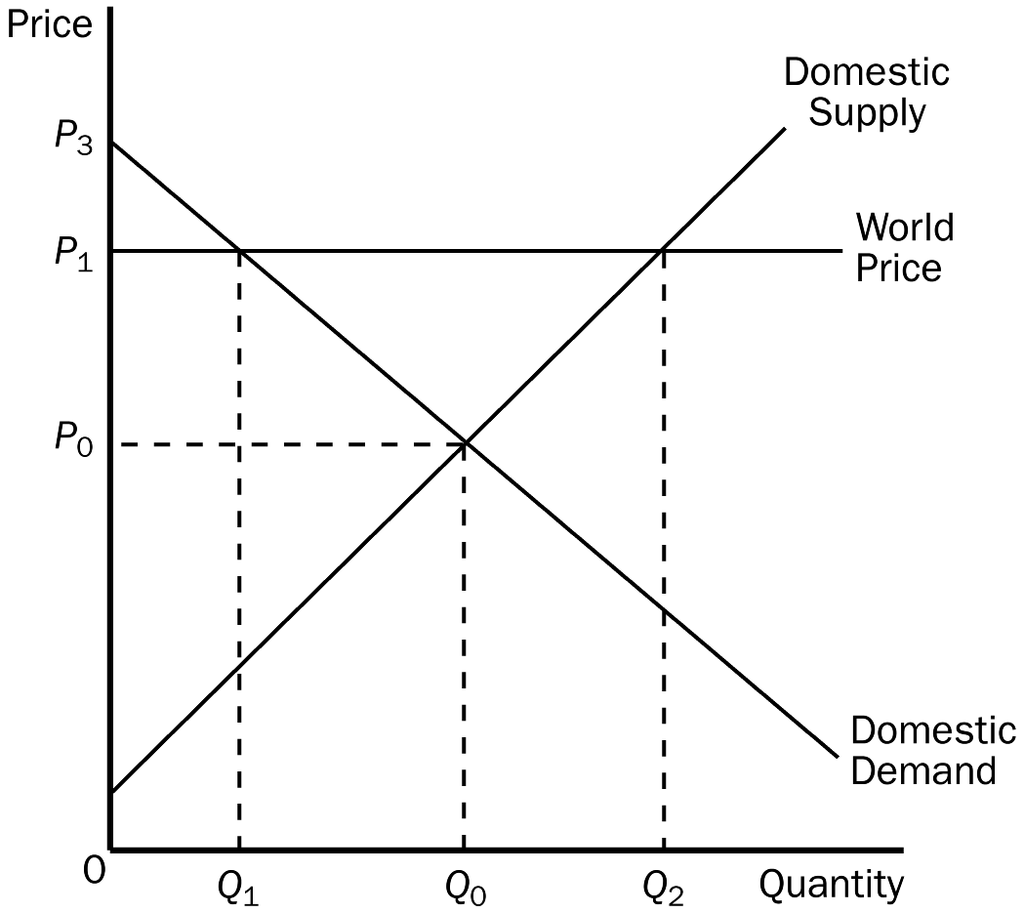
98. Refer to Figure 9-6. The equilibrium price and the equilibrium quantity of cheese in Wales before trade are
a. P₁ and Q_{2.}
b. P₁ and Q₁.
c. P₀ and Q₀.
d. P₀ and Q₁.
ANS: C PTS: 1 DIF: 1 REF: 9-2
TOP: Equilibrium price | Equilibrium quantity MSC: Interpretive
99. Refer to Figure 9-6. With trade, the Welsh price of cheese and the Welsh quantity of cheese demanded are
a. P₁ and Q₂.
b. P₁ and Q₁.
c. P₀ and Q₀.
d. P₃ and Q₁.
ANS: B PTS: 1 DIF: 2 REF: 9-2
TOP: Trade | Equilibrium MSC: Interpretive
100. Refer to Figure 9-6. With trade, Wales
a. imports Q₂ - Q₁ units of cheese.
b. exports Q₂ - Q₁ units of cheese.
c. imports Q₂ - Q₀ units of cheese.
d. exports Q₂ - Q₀ units of cheese.
ANS: B PTS: 1 DIF: 2 REF: 9-2
TOP: Exports MSC: Applicative
101. Refer to Figure 9-6. Which of the following is a valid equation for Welsh consumer surplus with trade?
a. Consumer surplus with trade = (1/2)(Q₀)(P₁ - P₀).
b. Consumer surplus with trade = (1/2)(Q₀)(P₃ - P₀).
c. Consumer surplus with trade = (1/2)(Q₁)(P₃ - P₁).
d. None of the above is correct.
ANS: C PTS: 1 DIF: 3 REF: 9-2
TOP: Trade | Consumer surplus MSC: Analytical
102. Refer to Figure 9-6. Which of the following is a valid equation for Welsh producer surplus with trade?
a. Producer surplus with trade = (1/2)P₀Q_{0.}
b. Producer surplus with trade = (1/2)P₁Q_{1.}
c. Producer surplus with trade = (1/2)P₁Q_{2.}
d. None of the above is correct.
ANS: D PTS: 1 DIF: 3 REF: 9-2
TOP: Trade | Producer surplus MSC: Analytical
103. Refer to Figure 9-6. Which of the following is a valid equation for the gains from trade?
a. Gains from trade = (1/2)(P₁ - P₀)(Q₂ - Q₁).
b. Gains from trade = (1/2)(P₁ - P₀)(Q₂ - Q₀)
c. Gains from trade = (1/2)(P₁ - P₀)(Q₁ + Q₂).
d. Gains from trade = (1/2)(Q₁)(P₃ - P₁).
ANS: A PTS: 1 DIF: 3 REF: 9-2
TOP: Gains from trade MSC: Analytical
Figure 9-7. On the diagram below, Q represents the quantity of cars and P represents the price of cars.
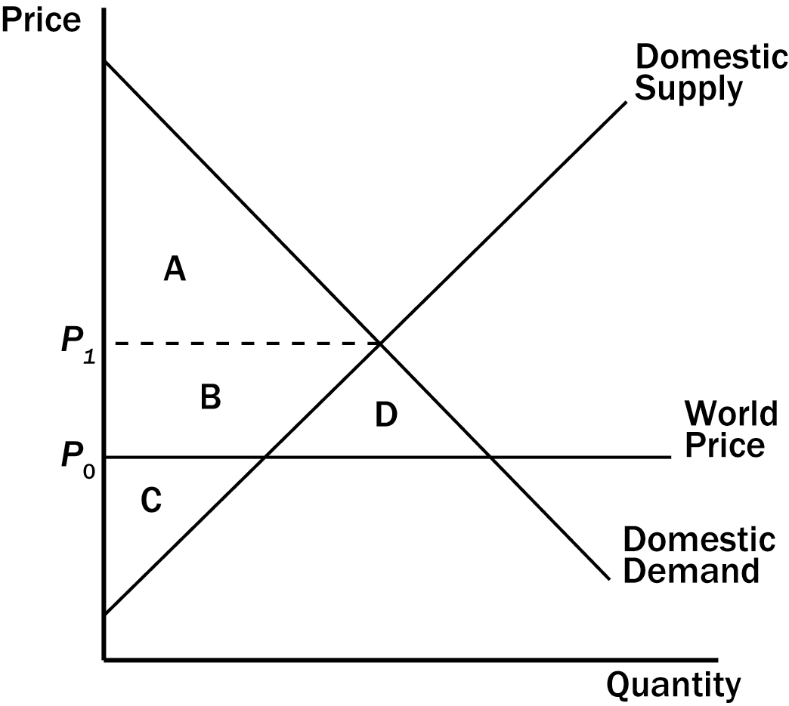
104. Refer to Figure 9-7. The price corresponding to the horizontal dotted line on the graph represents the price of cars
a. after trade is allowed.
b. before trade is allowed.
c. that maximizes total surplus when trade is allowed.
d. that minimizes the well-being of domestic car producers when trade is allowed.
ANS: B PTS: 1 DIF: 1 REF: 9-2
TOP: Equilibrium price MSC: Interpretive
105. Refer to Figure 9-7. The country for which the figure is drawn
a. has a comparative advantage relative to other countries in the production of cars and it will export cars.
b. has a comparative advantage relative to other countries in the production of cars and it will import cars.
c. has a comparative disadvantage relative to other countries in the production of cars and it will export cars.
d. has a comparative disadvantage relative to other countries in the production of cars and it will import cars.
ANS: D PTS: 1 DIF: 2 REF: 9-2
TOP: Comparative advantage | Imports MSC: Applicative
106. Refer to Figure 9-7. When the country for which the figure is drawn allows international trade in cars,
a. consumer surplus increases by the area B.
b. producer surplus decreases by the area B + D.
c. total surplus increases by the area D.
d. All of the above are correct.
ANS: C PTS: 1 DIF: 2 REF: 9-2
TOP: Imports | Economic Welfare MSC: Applicative
107. Refer to Figure 9-7. In the country for which the figure is drawn, total surplus with international trade in cars
a. is represented by the area A + B + C.
b. is represented by the area A + B + D.
c. is smaller than producer surplus without international trade in cars.
d. is larger than total surplus without international trade in cars.
ANS: D PTS: 1 DIF: 2 REF: 9-2
TOP: Imports | Economic Welfare MSC: Applicative
Figure 9-8
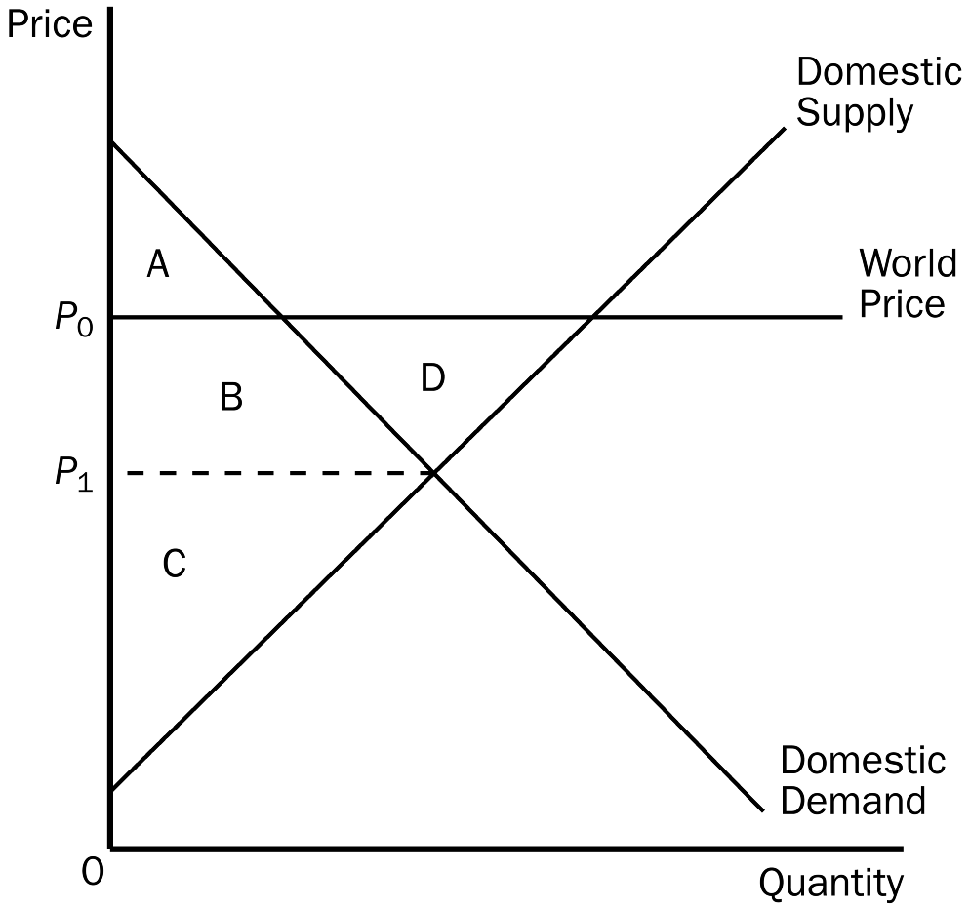
108. Refer to Figure 9-8. Consumer surplus in this market before trade is
a. A.
b. A + B.
c. A + B + D.
d. C.
ANS: B PTS: 1 DIF: 2 REF: 9-2
TOP: Consumer surplus MSC: Applicative
109. Refer to Figure 9-8. Consumer surplus in this market after trade is
a. A.
b. A + B.
c. A + B + D.
d. C.
ANS: A PTS: 1 DIF: 2 REF: 9-2
TOP: Trade | Consumer surplus MSC: Applicative
110. Refer to Figure 9-8. Producer surplus in this market before trade is
a. A.
b. A + B.
c. B + C + D.
d. C.
ANS: D PTS: 1 DIF: 2 REF: 9-2
TOP: Producer surplus MSC: Applicative
111. Refer to Figure 9-8. Producer surplus in this market after trade is
a. A.
b. A + B.
c. B + C + D.
d. C.
ANS: C PTS: 1 DIF: 2 REF: 9-2
TOP: Trade | Producer surplus MSC: Applicative
112. Refer to Figure 9-8. Total surplus in this market before trade is
a. A + B.
b. A + B + C.
c. A + B + C + D.
d. B + C + D.
ANS: B PTS: 1 DIF: 2 REF: 9-2
TOP: Total surplus MSC: Applicative
113. Refer to Figure 9-8. Total surplus in this market after trade is
a. A + B.
b. A + B + C.
c. A + B + C + D.
d. B + C + D.
ANS: C PTS: 1 DIF: 2 REF: 9-2
TOP: Trade | Total surplus MSC: Applicative
114. Refer to Figure 9-8. The change in total surplus in this market because of trade is
a. D, and this area represents a loss of total surplus because of trade.
b. D, and this area represents a gain in total surplus because of trade.
c. B + D, and this area represents a loss of total surplus because of trade.
d. B + D, and this area represents a gain in total surplus because of trade.
ANS: B PTS: 1 DIF: 2 REF: 9-2
TOP: Trade | Total surplus MSC: Applicative
Figure 9-9. The figure applies to the nation of Kenya and the good is air conditioners.
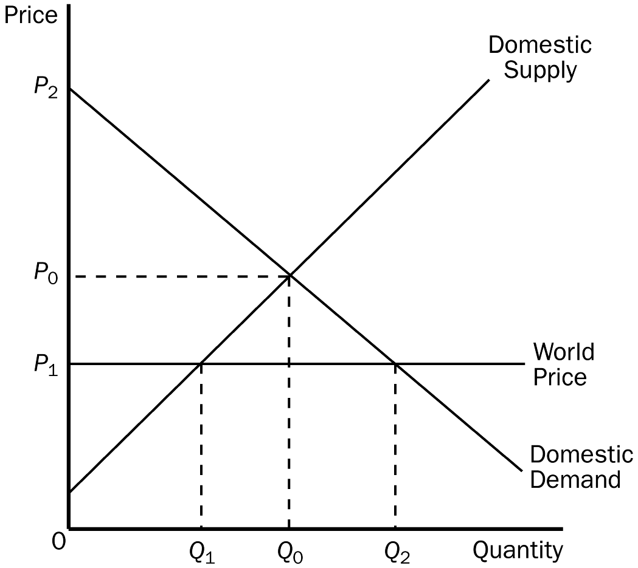
115. Refer to Figure 9-9. The price and quantity of air conditioners in Kenya before trade is
a. P₀ and Q₀.
b. P₁ and Q₁.
c. P₂ and Q₂.
d. P₁ and Q₀.
ANS: A PTS: 1 DIF: 1 REF: 9-2
TOP: Equilibrium price | Equilibrium quantity MSC: Interpretive
116. Refer to Figure 9-9. With trade, the equilibrium price of air conditioners and the equilibrium quantity of air conditioners demanded in Kenya are
a. P₁ and Q₁.
b. P₁ and Q₂.
c. P₂ and Q₂.
d. P₀ and Q₀.
ANS: B PTS: 1 DIF: 2 REF: 9-2
TOP: Trade | Equilibrium price | Equilibrium quantity MSC: Interpretive
117. Refer to Figure 9-9. When trade takes place, the quantity Q₂ - Q₁ is
a. the number of air conditioners bought and sold in Kenya.
b. the number of air conditioners produced in Kenya.
c. the number of air conditioners exported by Kenya.
d. the number of air conditioners imported by Kenya.
ANS: D PTS: 1 DIF: 2 REF: 9-2
TOP: Imports MSC: Applicative
118. Refer to Figure 9-9. Kenya’s gains from trade are represented by the area that is bounded by the points
a. (0, P₀), (Q₀, P₀), (Q₂, P₁), and (0, P₁).
b. (0, P₁), (0, P₂), (Q₀, P₀), and (Q₁, P₁).
c. (Q₀, P₀), (Q₂, P₁), and (Q₁, P₁).
d. (0, P₀), (0, P₂), and (Q₀, P₀).
ANS: C PTS: 1 DIF: 3 REF: 9-2
TOP: Gains from trade MSC: Analytical
119. Refer to Figure 9-9. The area bounded by the points (Q₀, P₀), (Q₂, P₁), and (Q₁, P₁) represents
a. Kenya’s gains from trade.
b. the amount by which Kenya’s gain in consumer surplus exceeds its loss in producer surplus due to trade.
c. Kenya’s gain in total surplus due to trade.
d. All of the above are correct.
ANS: D PTS: 1 DIF: 3 REF: 9-2
TOP: Gains from trade MSC: Analytical
120. Refer to Figure 9-9. The area bounded by the points (Q₀, P₀), (Q₂, P₁), and (Q₁, P₁) represents
a. Kenya’s gains from trade.
b. the amount by which Kenya’s gain in producer surplus exceeds its loss in consumer surplus due to trade.
c. Kenya’s loss in total surplus due to trade.
d. All of the above are correct.
ANS: A PTS: 1 DIF: 3 REF: 9-2
TOP: Gains from trade MSC: Analytical
Figure 9-10
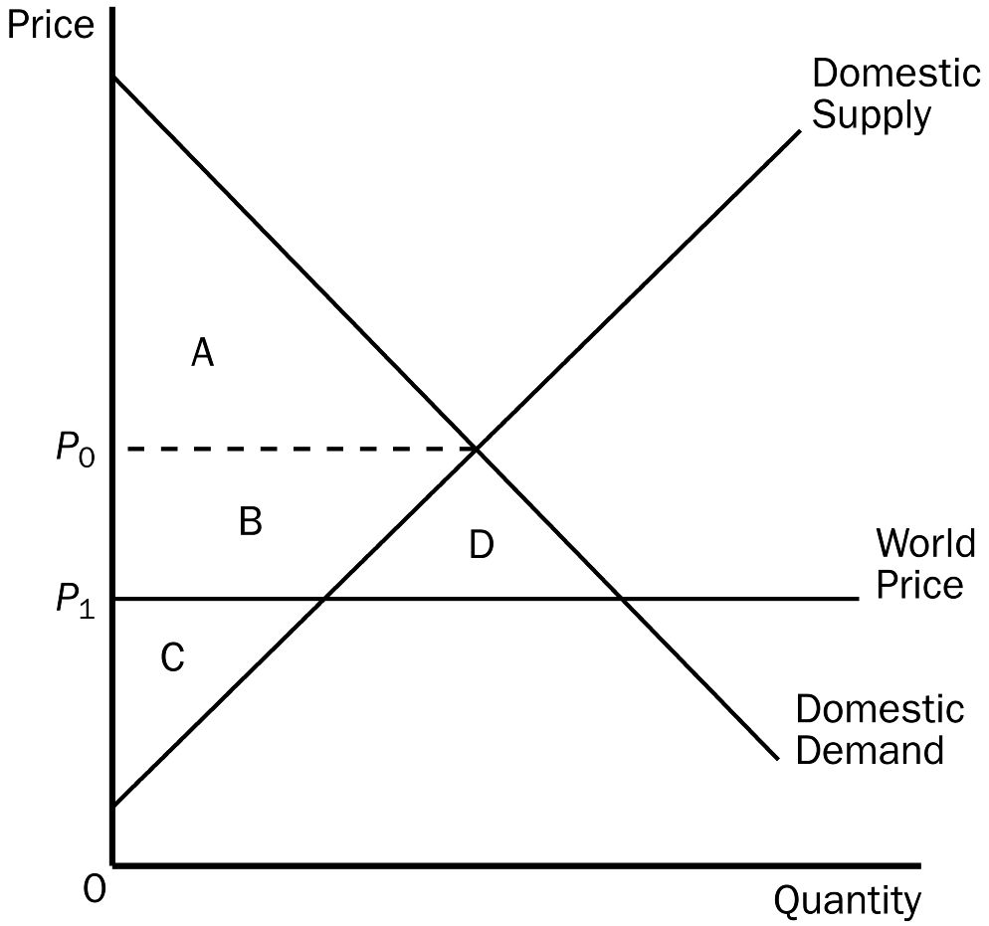
121. Refer to Figure 9-10. Consumer surplus in this market before trade is
a. A.
b. B + C.
c. A + B + D.
d. C.
ANS: A PTS: 1 DIF: 2 REF: 9-2
TOP: Consumer surplus MSC: Applicative
122. Refer to Figure 9-10. Consumer surplus in this market after trade is
a. A.
b. C + B.
c. A + B + D.
d. B + C + D.
ANS: C PTS: 1 DIF: 2 REF: 9-2
TOP: Trade | Consumer surplus MSC: Applicative
123. Refer to Figure 9-10. Producer surplus in this market before trade is
a. C.
b. B + C.
c. A + B + D.
d. B + C + D.
ANS: B PTS: 1 DIF: 2 REF: 9-2
TOP: Producer surplus MSC: Applicative
124. Refer to Figure 9-10. Producer surplus in this market after trade is
a. C.
b. C + B.
c. A + B + D.
d. B + C + D.
ANS: A PTS: 1 DIF: 2 REF: 9-2
TOP: Trade | Producer surplus MSC: Applicative
125. Refer to Figure 9-10. Producer surplus plus consumer surplus in this market before trade is
a. A + B.
b. A + B + C.
c. A + B + C + D.
d. B + C + D.
ANS: B PTS: 1 DIF: 2 REF: 9-2
TOP: Total surplus MSC: Applicative
126. Refer to Figure 9-10. Producer surplus plus consumer surplus in this market after trade is
a. A + B.
b. A + B + C.
c. B + C + D.
d. A + B + C + D.
ANS: D PTS: 1 DIF: 2 REF: 9-2
TOP: Trade | Total surplus MSC: Applicative
127. Refer to Figure 9-10. The change in total surplus in this market because of trade is
a. A, and this area represents a loss of total surplus.
b. B, and this area represents a gain in total surplus.
c. C, and this area represents a loss of total surplus.
d. D, and this area represents a gain in total surplus.
ANS: D PTS: 1 DIF: 2 REF: 9-2
TOP: Trade | Total surplus MSC: Applicative
Figure 9-11
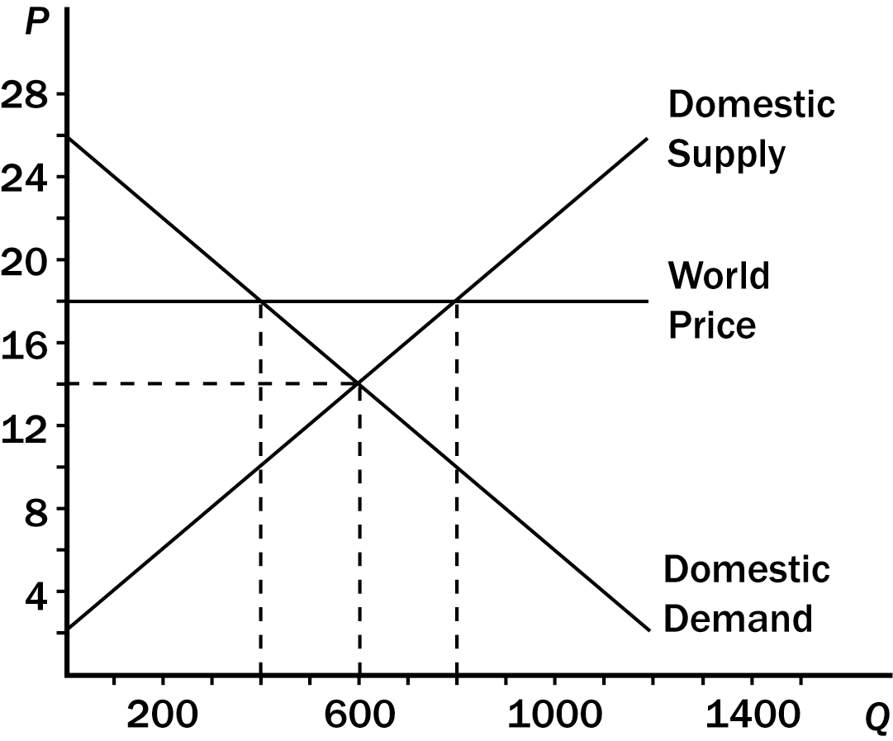
128. Refer to Figure 9-11. Equilibrium price and equilibrium quantity without trade are
a. $18 and 400.
b. $18 and 800.
c. $14 and 400.
d. $14 and 600.
ANS: D PTS: 1 DIF: 1 REF: 9-2
TOP: Equilibrium price | Equilibrium quantity MSC: Interpretive
129. Refer to Figure 9-11. With trade, the domestic price and domestic quantity demanded are
a. $18 and 400.
b. $18 and 800.
c. $14 and 400.
d. $14 and 600.
ANS: A PTS: 1 DIF: 2 REF: 9-2
TOP: Trade | Equilibrium MSC: Interpretive
130. Refer to Figure 9-11. With trade, domestic production and domestic consumption, respectively, are
a. 600 and 400.
b. 800 and 400.
c. 400 and 600.
d. 400 and 800.
ANS: B PTS: 1 DIF: 2 REF: 9-2
TOP: Trade | Equilibrium quantity MSC: Applicative
131. Refer to Figure 9-11. Consumer surplus before trade is
a. $1,600.
b. $2,400.
c. $3,200.
d. $3,600.
ANS: D PTS: 1 DIF: 2 REF: 9-2
TOP: Consumer surplus MSC: Applicative
132. Refer to Figure 9-11. Consumer surplus after trade is
a. $1,600.
b. $2,400.
c. $3,200.
d. $3,600.
ANS: A PTS: 1 DIF: 2 REF: 9-2
TOP: Trade | Consumer surplus MSC: Applicative
133. Refer to Figure 9-11. Producer surplus before trade is
a. $3,600.
b. $4,400.
c. $5,200.
d. $6,600.
ANS: A PTS: 1 DIF: 2 REF: 9-2
TOP: Producer surplus MSC: Applicative
134. Refer to Figure 9-11. Producer surplus after trade is
a. $4,800.
b. $5,600.
c. $6,400.
d. $7,000.
ANS: C PTS: 1 DIF: 2 REF: 9-2
TOP: Trade | Producer surplus MSC: Applicative
135. Refer to Figure 9-11. With trade allowed, this country
a. exports 200 units of the good.
b. exports 400 units of the good.
c. imports 200 units of the good.
d. exports 800 units of the good.
ANS: B PTS: 1 DIF: 2 REF: 9-2
TOP: Exports MSC: Applicative
Figure 9-12
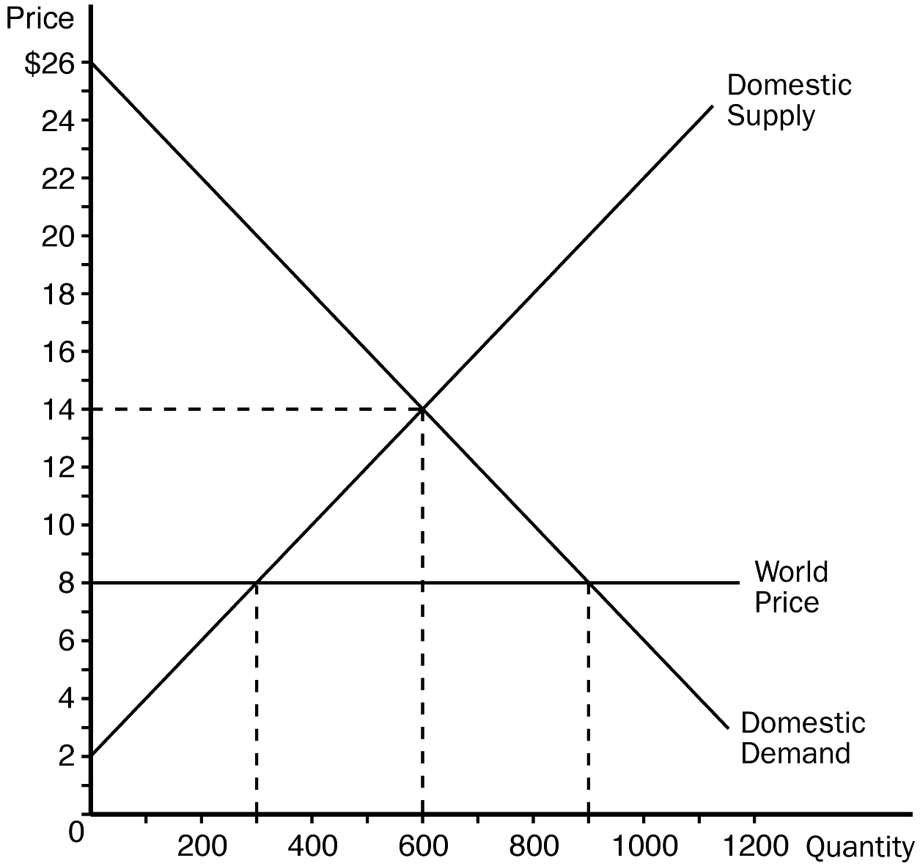
136. Refer to Figure 9-12. The price and domestic quantity demanded after trade are
a. $8 and 300.
b. $8 and 900.
c. $14 and 900.
d. $14 and 600.
ANS: B PTS: 1 DIF: 2 REF: 9-2
TOP: Trade | Equilibrium price | Equilibrium quantity MSC: Applicative
137. Refer to Figure 9-12. With trade, domestic production and domestic consumption, respectively, are
a. 600 and 600.
b. 600 and 300.
c. 300 and 900.
d. 600 and 900.
ANS: C PTS: 1 DIF: 2 REF: 9-2
TOP: Trade | Equilibrium MSC: Applicative
138. Refer to Figure 9-12. Consumer surplus before trade is
a. $1,600.
b. $,2400.
c. $3,200.
d. $3,600.
ANS: D PTS: 1 DIF: 2 REF: 9-2
TOP: Consumer surplus MSC: Applicative
139. Refer to Figure 9-12. Consumer surplus after trade is
a. $3,600.
b. $5,400.
c. $7,200.
d. $8,100.
ANS: D PTS: 1 DIF: 2 REF: 9-2
TOP: Trade | Consumer surplus MSC: Applicative
140. Refer to Figure 9-12. Producer surplus before trade is
a. $3,600.
b. $4,400.
c. $5,200.
d. $6,600.
ANS: A PTS: 1 DIF: 2 REF: 9-2
TOP: Producer surplus MSC: Applicative
141. Refer to Figure 9-12. With trade, producer surplus is
a. $900.
b. $1,100.
c. $1,500.
d. $2,000.
ANS: A PTS: 1 DIF: 2 REF: 9-2
TOP: Trade | Producer surplus MSC: Applicative
142. Refer to Figure 9-12. With trade, the country
a. exports 200 units of the good.
b. exports 400 units of the good.
c. imports 400 units of the good.
d. imports 600 units of the good.
ANS: D PTS: 1 DIF: 2 REF: 9-2
TOP: Imports MSC: Applicative
Figure 9-13. On the diagram below, Q represents the quantity of computers and P represents the price of computers.
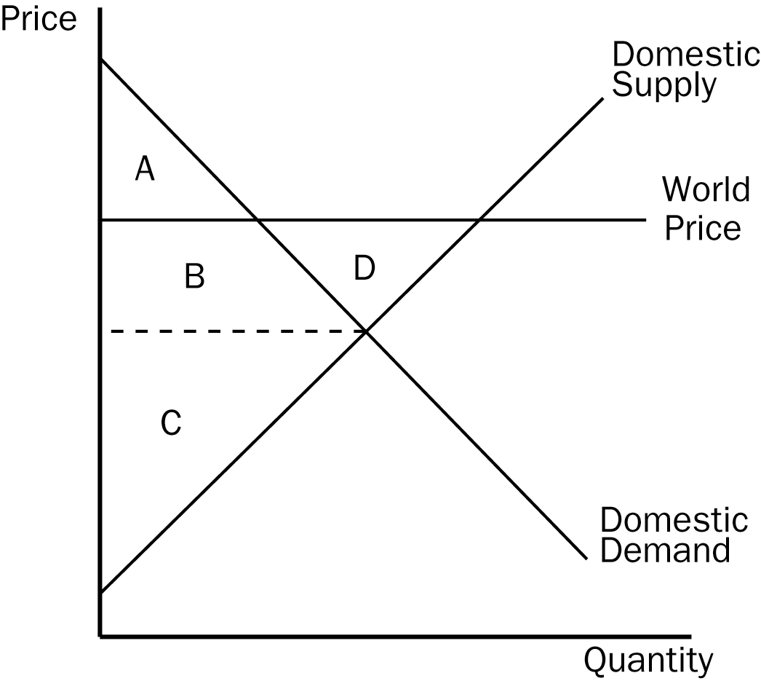
143. Refer to Figure 9-13. As a result of international trade in computers being allowed, which of the following statements is correct for the country for which the figure is drawn?
a. Consumer surplus for domestic computer consumers decreases.
b. The demand for computers by domestic computer consumers decreases.
c. The losses of the domestic losers outweigh the gains of the domestic winners.
d. Domestic computer producers sell fewer computers.
ANS: A PTS: 1 DIF: 2 REF: 9-2
TOP: Exports | Economic Welfare MSC: Applicative
144. Refer to Figure 9-13. When the country for which the figure is drawn allows international trade in computers,
a. consumer surplus changes from the area A + B + D to the area A.
b. producer surplus changes from the area C to the area B + C + D.
c. total surplus decreases by the area D.
d. All of the above are correct.
ANS: B PTS: 1 DIF: 2 REF: 9-2
TOP: Exports | Economic Welfare MSC: Applicative
145. Refer to Figure 9-13. The country for which the figure is drawn
a. has a comparative advantage relative to other countries in the production of computers and it will export computers.
b. has a comparative advantage relative to other countries in the production of computers and it will import computers.
c. has a comparative disadvantage relative to other countries in the production of computers and it will export computers.
d. has a comparative disadvantage relative to other countries in the production of computers and it will import computers.
ANS: A PTS: 1 DIF: 2 REF: 9-2
TOP: Comparative advantage | Exports MSC: Applicative
146. Refer to Figure 9-13. A result of this country allowing international trade in computers is as follows:
a. The well-being of domestic computer producers is now higher in that they now sell more computers at a higher price per computer.
b. The effect on the well-being of domestic computer consumers is unclear in that they now buy more computers, but at a higher price per computer.
c. The effect on the well-being of the country is unclear in that domestic producer surplus increases, while the effect on domestic consumer surplus is unclear.
d. All of the above are correct.
ANS: A PTS: 1 DIF: 2 REF: 9-2
TOP: Exports | Economic Welfare MSC: Applicative
147. A tariff on a product makes
a. domestic sellers better off and domestic buyers worse off.
b. domestic sellers worse off and domestic buyers worse off.
c. domestic sellers better off and domestic buyers better off.
d. domestic sellers worse off and domestic buyers better off.
ANS: A PTS: 1 DIF: 2 REF: 9-2
TOP: Tariffs MSC: Interpretive
148. A tariff on a product
a. is a direct quantitative restriction on the amount of a good that can be imported.
b. increases the domestic quantity supplied.
c. increases domestic consumer surplus.
d. All of the above are correct.
ANS: B PTS: 1 DIF: 2 REF: 9-2
TOP: Tariffs MSC: Interpretive
149. A tariff on a product
a. enhances the economic well-being of the domestic economy.
b. increases the domestic quantity supplied.
c. increases the domestic quantity demanded.
d. results in an increase in producer surplus that is greater than the resulting decrease in consumer surplus.
ANS: B PTS: 1 DIF: 2 REF: 9-2
TOP: Tariffs | Economic welfare MSC: Interpretive
150. If the United States imposes a tariff on automobiles, then
a. total surplus in the American automobile market decreases.
b. producer surplus in the American automobile market increases.
c. U.S. imports of foreign automobiles decrease.
d. All of the above are correct.
ANS: D PTS: 1 DIF: 2 REF: 9-2
TOP: Tariffs | Economic welfare MSC: Interpretive
151. A tariff is a tax placed on
a. an exported good and it lowers the domestic price of the good below the world price.
b. an exported good and it ensures that the domestic price of the good stays the same as the world price.
c. an imported good and it lowers the domestic price of the good below the world price.
d. an imported good and it raises the domestic price of the good above the world price.
ANS: D PTS: 1 DIF: 2 REF: 9-2
TOP: Tariffs | Prices MSC: Interpretive
152. A tariff
a. lowers the domestic price of the exported good below the world price.
b. keeps the domestic price of the exported good the same as the world price.
c. raises the domestic price of the imported good above the world price.
d. lowers the domestic price of the imported good below the world price.
ANS: C PTS: 1 DIF: 2 REF: 9-2
TOP: Tariffs | Prices MSC: Interpretive
153. When a country moves away from a free trade position and imposes a tariff on imports, this causes
a. a decrease in total surplus in the market.
b. a decrease in producer surplus in the market.
c. an increase in consumer surplus in the market.
d. a decrease in revenue to the government.
ANS: A PTS: 1 DIF: 2 REF: 9-2
TOP: Tariffs | Economic welfare MSC: Interpretive
154. If the demand curve and the supply curve for a good are straight lines, then the deadweight loss that results from a tariff is represented on the supply-and-demand graph by
a. the area of one triangle.
b. the area of one rectangle.
c. the combined areas of two different triangles.
d. the combined areas of two different rectangles.
ANS: C PTS: 1 DIF: 2 REF: 9-2
TOP: Tariffs | Deadweight losses MSC: Interpretive
155. Suppose Mexico imposes a tariff on lumber. For the tariff to have any effect, it must be the case that
a. Mexico is an exporter of lumber.
b. the domestic quantity supplied exceeds the domestic quantity demanded at the world price without the tariff.
c. the world price without the tariff is less than the price of lumber without trade.
d. the world price without the tariff is greater than the price of lumber without trade.
ANS: C PTS: 1 DIF: 2 REF: 9-2
TOP: Tariffs MSC: Interpretive
156. Denmark is an importer of computer chips, taking the world price of $12 per chip as given. Suppose Denmark imposes a $5 tariff on chips. As a result,
a. Danish consumers of chips and Danish producers of chips both gain.
b. Danish consumers of chips gain and Danish producers of chips lose.
c. Danish consumers of chips lose and Danish producers of chips gain.
d. Danish consumers of chips and Danish producers of chips both lose.
ANS: C PTS: 1 DIF: 2 REF: 9-2
TOP: Tariffs | Economic welfare MSC: Interpretive
157. Denmark is an importer of computer chips, taking the world price of $12 per chip as given. Suppose Denmark imposes a $5 tariff on chips. Which of the following outcomes is possible?
a. More Danish-produced chips are sold in Denmark.
b. More foreign-produced chips are sold in Denmark.
c. Danish consumers of chips become better off.
d. Total surplus in the Danish chip market increases.
ANS: A PTS: 1 DIF: 2 REF: 9-2
TOP: Tariffs | Economic welfare MSC: Applicative
158. Denmark is an importer of computer chips, taking the world price of $12 per chip as given. Suppose Denmark imposes a $5 tariff on chips. Which of the following outcomes is possible?
a. The price of chips in Denmark increases to $19; the quantity of Danish-produced chips increases; and the quantity of chips imported by Denmark decreases.
b. The price of chips in Denmark increases to $17; the quantity of Danish-produced chips increases; and the quantity of chips imported by Denmark decreases.
c. The price of chips in Denmark increases to $17; the quantity of Danish-produced chips increases; and the quantity of chips imported by Denmark increases.
d. The price of chips in Denmark increases to $15; the quantity of Danish-produced chips increases; and the quantity of chips imported by Denmark decreases.
ANS: B PTS: 1 DIF: 3 REF: 9-2
TOP: Tariffs | Prices MSC: Analytical
159. Turkey is an importer of goose-down pillows. The world price of these pillows is $50. Turkey imposes a $7 tariff on pillows. Turkey is a price-taker in the pillow market. As a result of the tariff, the price of goose-down pillows in Turkey
a. remains at $50 and the quantity of goose-down pillows purchased in Turkey decreases.
b. increases to $57 and the quantity of goose-down pillows purchased in Turkey decreases.
c. increases to a new price between $50 and $57 and the quantity of goose-down pillows purchased in Turkey decreases.
d. increases to a new price above $57 and the quantity of goose-down pillows purchased in Turkey remains the same.
ANS: B PTS: 1 DIF: 3 REF: 9-2
TOP: Tariffs | Equilibrium MSC: Applicative
160. Turkey is an importer of goose-down pillows. The world price of these pillows is $50. Turkey imposes a $7 tariff on pillows. Turkey is a price-taker in the pillow market. As a result of the tariff,
a. Turkish consumers of pillows become worse off and Turkish producers of pillows become worse off.
b. Turkish consumers of pillows become worse off and Turkish producers of pillows become better off.
c. Turkish consumers of pillows become better off and Turkish producers of pillows become worse off.
d. Turkish consumers of pillows become better off and Turkish producers of pillows become better off.
ANS: B PTS: 1 DIF: 2 REF: 9-2
TOP: Tariffs | Economic welfare MSC: Interpretive
Figure 9-14
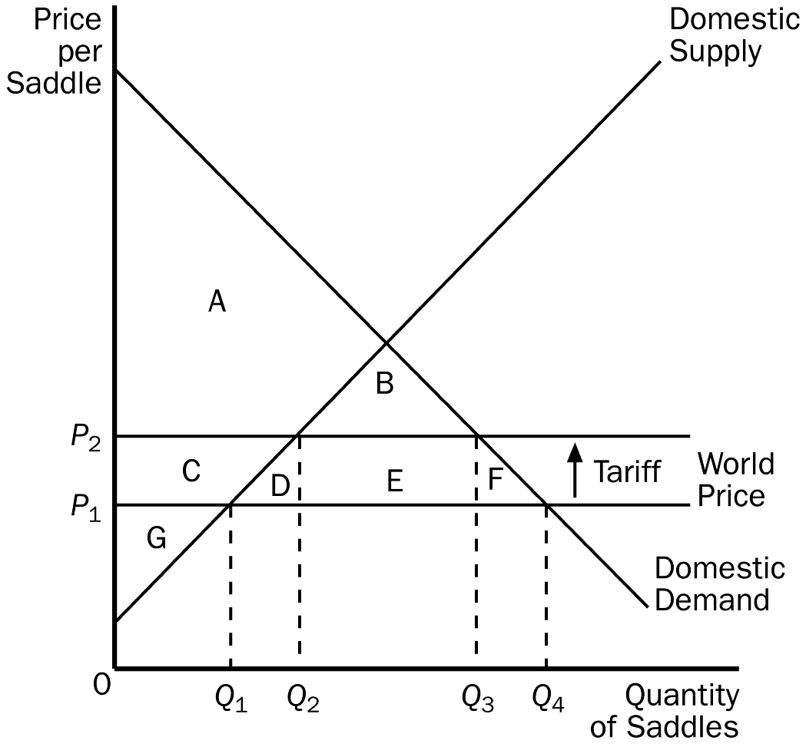
161. Refer to Figure 9-14. With trade and without a tariff, the price and domestic quantity demanded are
a. P₁ and Q₁.
b. P₁ and Q₄.
c. P₂ and Q₂.
d. P₂ and Q₃.
ANS: B PTS: 1 DIF: 2 REF: 9-2
TOP: Trade | Equilibrium MSC: Interpretive
162. Refer to Figure 9-14. With the tariff, the domestic price and domestic quantity demanded are
a. P₁ and Q₁.
b. P₁ and Q₄.
c. P₂ and Q₂.
d. P₂ and Q₃.
ANS: D PTS: 1 DIF: 2 REF: 9-2
TOP: Tariffs | Equilibrium MSC: Applicative
163. Refer to Figure 9-14. With the tariff, the quantity of saddles imported is
a. Q₃ - Q₁.
b. Q₃ - Q₂.
c. Q₄ - Q₁.
d. Q₄ - Q₂.
ANS: B PTS: 1 DIF: 2 REF: 9-2
TOP: Tariffs | Imports MSC: Applicative
164. Refer to Figure 9-14. A result of the tariff is that, relative to the free-trade situation, the quantity of saddles imported decreases by
a. Q₂ - Q₁.
b. Q₃ - Q₂.
c. Q₄ - Q₃.
d. Q₄ - Q₃ + Q₂ - Q₁.
ANS: D PTS: 1 DIF: 3 REF: 9-2
TOP: Tariffs | Imports MSC: Applicative
165. Refer to Figure 9-14. Consumer surplus with trade and without a tariff is
a. A.
b. A + B.
c. A + C + G.
d. A + B + C + D + E + F.
ANS: D PTS: 1 DIF: 2 REF: 9-2
TOP: Trade | Consumer surplus MSC: Applicative
166. Refer to Figure 9-14. Producer surplus with trade and without a tariff is
a. G.
b. C + G.
c. A + C + G.
d. A + B + C + G.
ANS: A PTS: 1 DIF: 2 REF: 9-2
TOP: Trade | Producer surplus MSC: Applicative
167. Refer to Figure 9-14. Consumer surplus with the tariff is
a. A.
b. A + B.
c. A + C + G.
d. A + B + C + D +E + F.
ANS: B PTS: 1 DIF: 2 REF: 9-2
TOP: Tariffs | Consumer surplus MSC: Applicative
168. Refer to Figure 9-14. Producer surplus with the tariff is
a. G.
b. C + G.
c. A + C + G.
d. A + B + C + G.
ANS: B PTS: 1 DIF: 2 REF: 9-2
TOP: Tariffs | Producer surplus MSC: Applicative
169. Refer to Figure 9-14. The amount of government revenue created by the tariff is
a. B.
b. E.
c. D + F.
d. B + D + E + F.
ANS: B PTS: 1 DIF: 2 REF: 9-2
TOP: Tariffs | Government MSC: Applicative
170. Refer to Figure 9-14. As a result of the tariff, there is a deadweight loss that amounts to
a. B.
b. E.
c. D + F.
d. B + D + E + F.
ANS: C PTS: 1 DIF: 2 REF: 9-2
TOP: Tariffs | Deadweight losses MSC: Applicative
171. Refer to Figure 9-14. For the saddle market, area B represents
a. government’s revenue from the tariff.
b. the deadweight loss of the tariff.
c. the increase in producer surplus, relative to the free-trade situation, as a result of the tariff.
d. None of the above is correct.
ANS: D PTS: 1 DIF: 3 REF: 9-2
TOP: Trade | Tariffs MSC: Applicative
Figure 9-15. The figure below illustrates a tariff. On the graph, Q represents quantity and P represents price.
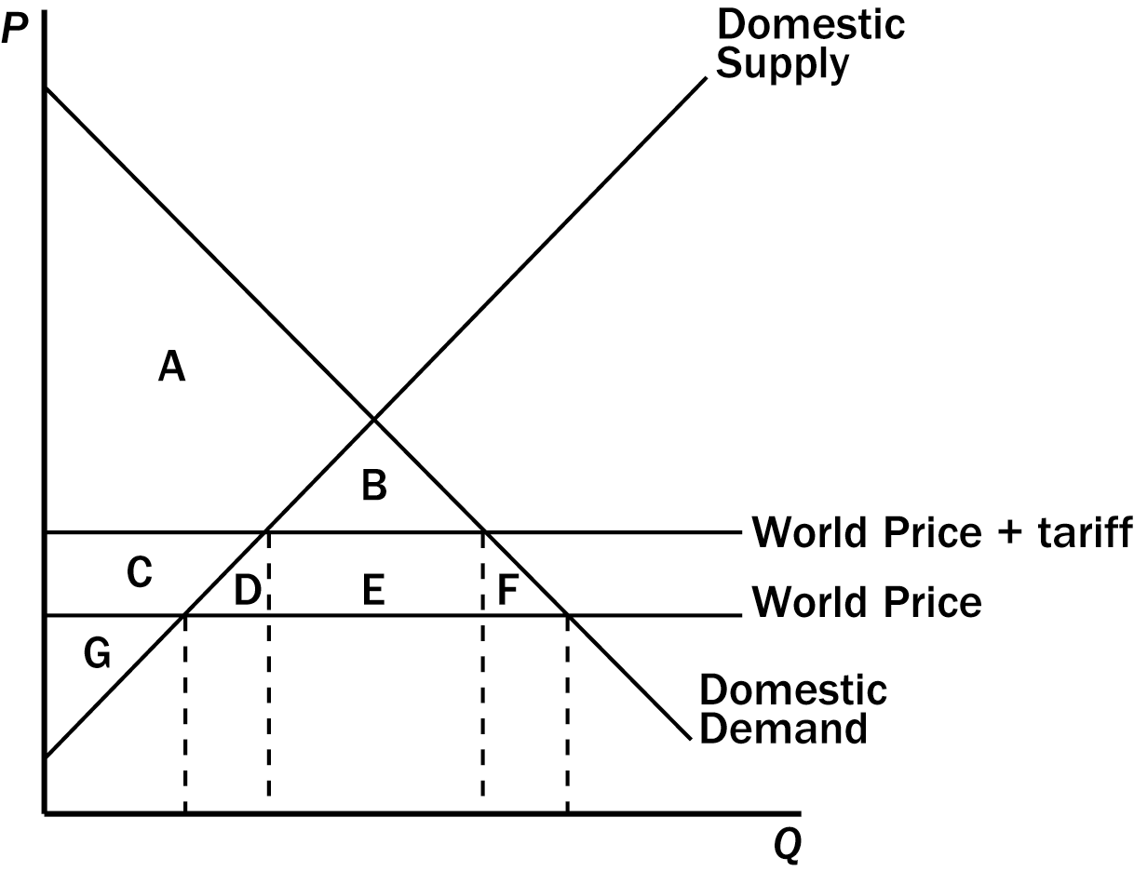
172. Refer to Figure 9-15. Government revenue raised by the tariff is represented by the area
a. E.
b. B + E.
c. D + E + F.
d. B + D + E + F.
ANS: A PTS: 1 DIF: 2 REF: 9-2
TOP: Tariffs | Government MSC: Applicative
173. Refer to Figure 9-15. The tariff
a. decreases producer surplus by the area C and decreases consumer surplus by the area C + D + E + F.
b. decreases producer surplus by the area C + D and decreases consumer surplus by the area D + E + F.
c. increases producer surplus by the area C and decreases consumer surplus by the area C + D + E + F.
d. increases producer surplus by the area B + C and decrease consumer surplus by the area D + E + F.
ANS: C PTS: 1 DIF: 2 REF: 9-2
TOP: Tariffs | Economic Welfare MSC: Applicative
174. Refer to Figure 9-15. The deadweight loss created by the tariff is represented by the area
a. B.
b. D + F.
c. D + E + F.
d. B + D + E + F.
ANS: B PTS: 1 DIF: 2 REF: 9-2
TOP: Tariffs | Deadweight losses MSC: Applicative
175. A quota is
a. a tax placed on imports.
b. a limit on the quantity of imports.
c. a tax on exports to other countries.
d. an excess of exports over imports.
ANS: B PTS: 1 DIF: 1 REF: 9-2
TOP: Import quotas MSC: Definitional
176. Both tariffs and import quotas
a. increase the quantity of imports and raise the domestic price of the good.
b. increase the quantity of imports and lower the domestic price of the good.
c. decrease the quantity of imports and raise the domestic price of the good.
d. decrease the quantity of imports and lower the domestic price of the good.
ANS: C PTS: 1 DIF: 2 REF: 9-2
TOP: Tariffs | Import quotas MSC: Interpretive
177. A major difference between tariffs and import quotas is that
a. tariffs create deadweight losses, but import quotas do not.
b. tariffs help domestic consumers, and import quotas help domestic producers.
c. tariffs raise revenue for the government, but import quotas create surplus for those who get the licenses to import.
d. All of the above are correct.
ANS: C PTS: 1 DIF: 2 REF: 9-2
TOP: Tariffs | Import quotas MSC: Interpretive
178. Tariffs and quotas are different in the sense that
a. tariffs cause deadweight losses, while quotas do not cause deadweight losses.
b. tariffs raise revenue for the government, while quotas do not raise revenue for the government.
c. tariffs enhance the well-being of domestic consumers, while quotas diminish the well-being of domestic consumers.
d. tariffs enhance the well-being of domestic producers, while quotas diminish the well-being of domestic producers.
ANS: B PTS: 1 DIF: 2 REF: 9-2
TOP: Tariffs | Economic Welfare MSC: Interpretive
179. Import quotas and tariffs produce similar results. Which of the following is not one of those results?
a. The domestic price of the good increases.
b. Consumer surplus of domestic consumers increases.
c. Producer surplus of domestic producers increases.
d. A deadweight loss is experienced by the domestic country.
ANS: B PTS: 1 DIF: 2 REF: 9-2
TOP: Tariffs | Import quotas MSC: Interpretive
180. Import quotas and tariffs produce some common results. Which of the following is not one of those common results?
a. total surplus in the domestic country falls.
b. Producer surplus in the domestic country increases.
c. The domestic country experiences a deadweight loss.
d. Revenue is raised for the domestic government.
ANS: D PTS: 1 DIF: 2 REF: 9-2
TOP: Tariffs | Import quotas MSC: Interpretive
181. An import quota
a. is preferable to a tariff since an import quota does not create a deadweight loss.
b. is a tax on imported goods.
c. reduces the welfare of domestic consumers.
d. reduces the welfare of domestic producers.
ANS: C PTS: 1 DIF: 2 REF: 9-2
TOP: Import quotas MSC: Interpretive
182. Aquilonia has decided to end its policy of not trading with the rest of the world. When it ends its trade restrictions, it discovers that it is importing incense, exporting steel, and neither importing nor exporting rugs. We can conclude that Aquilonia’s new free-trade policy has
a. increased consumer surplus and producer surplus in the incense market.
b. increased consumer surplus in the steel market and left producer surplus in the rug market unchanged.
c. decreased consumer surplus in both the steel and rug markets.
d. decreased consumer surplus in the steel market and increased total surplus in the incense market.
ANS: D PTS: 1 DIF: 3 REF: 9-2
TOP: Trade | Economic welfare MSC: Applicative
183. Aquilonia has decided to end its policy of not trading with the rest of the world. When it ends its trade restrictions, it discovers that it is importing incense, exporting steel, and neither importing nor exporting rugs. We can conclude that producer surplus in Aquilonia is now
a. higher in the steel market, lower in the incense market, and unchanged in the rug market.
b. higher in the incense and steel markets, and unchanged in the rug market.
c. lower in the incense and rug markets, and higher in the steel market.
d. lower in the incense and steel markets, and the same in the rug market.
ANS: A PTS: 1 DIF: 3 REF: 9-2
TOP: Trade | Economic welfare MSC: Applicative
184. Aquilonia has decided to end its policy of not trading with the rest of the world. When it ends its trade restrictions, it discovers that it is importing incense, exporting steel, and neither importing nor exporting rugs. Which groups in Aquilonia are better off as a result of the new free-trade policy?
a. producers of incense and consumers of steel
b. consumers of all three goods
c. consumers of incense and producers of rugs
d. producers of steel and consumers of incense
ANS: D PTS: 1 DIF: 3 REF: 9-2
TOP: Trade | Economic welfare MSC: Applicative
185. The United States has imposed taxes on some imported goods that have been sold here by foreign countries at below their cost of production. These taxes
a. benefit the United States as a whole, because they generate revenue for the government. In addition, because the goods are priced below cost, the taxes do not harm domestic consumers.
b. benefit the United States as a whole, because they generate revenue for the government and increase producer surplus.
c. harm the United States as a whole, because they reduce consumer surplus by an amount that exceeds the gain in producer surplus and government revenue.
d. harm the United States as a whole, because they reduce the sum of consumer and producer surplus by an amount that exceeds the increase in government revenue.
ANS: C PTS: 1 DIF: 3 REF: 9-2
TOP: Tariffs | Economic welfare MSC: Applicative
186. At the end of 2004, the United States
a. vastly expanded its openness to imports of electronic devices from China.
b. vastly expanded its openness to imports of textiles from China.
c. imposed significant quotas on imports of electronic devices from China.
d. imposed significant quotas on imports of textiles from China.
ANS: B PTS: 1 DIF: 1 REF: 9-2
TOP: Import quotas MSC: Definitional
187. At the end of 2004, the United States government changed its policies pertaining to imports of textiles from China, with the result that
a. both American consumers of textiles and American producers of textiles experienced gains in surplus.
b. American consumers of textiles experienced a gain in surplus, while American producers of textiles experienced a loss of surplus.
c. American consumers of textiles experienced a loss of surplus, while American producers of textiles experienced a gain in surplus.
d. both American consumers of textiles and American producers of textiles experienced losses of surplus.
ANS: B PTS: 1 DIF: 2 REF: 9-2
TOP: Import quotas | Economic welfare MSC: Applicative
188. Which of the following arguments for trade restrictions is often advanced?
a. Trade restrictions make all Americans better off.
b. Trade restrictions increase economic efficiency.
c. Trade restrictions are necessary for economic growth.
d. Trade restrictions are sometimes necessary for national security.
ANS: D PTS: 1 DIF: 2 REF: 9-3
TOP: Trade policy MSC: Interpretive
189. Several arguments for restricting trade have been advanced. Those arguments do not include
a. the jobs argument.
b. the protection-as-a-bargaining-chip argument.
c. the no-deadweight-loss argument.
d. the infant-industry argument.
ANS: C PTS: 1 DIF: 1 REF: 9-3
TOP: Trade policy MSC: Interpretive
190. Countries usually impose restrictions on trade with other countries in order to protect
a. foreign producers.
b. foreign consumers.
c. domestic producers.
d. domestic consumers.
ANS: C PTS: 1 DIF: 1 REF: 9-3
TOP: Trade policy MSC: Interpretive
191. Which of the following is not a commonly advanced argument for trade restrictions?
a. the jobs argument
b. the national-security argument
c. the infant-industry argument
d. the efficiency argument
ANS: D PTS: 1 DIF: 1 REF: 9-3
TOP: Trade policy MSC: Definitional
192. Workers displaced by trade eventually find jobs in
a. another country.
b. the government sector.
c. the industries in which the country has a comparative advantage.
d. a different company in the same industry.
ANS: C PTS: 1 DIF: 1 REF: 9-3
TOP: Trade | Employment MSC: Interpretive
193. The infant-industry argument
a. is based on the belief that protecting industries when they are young will pay off later.
b. is based on the belief that protecting industries producing goods and services for infants is necessary if a country is to have healthy children.
c. has the support of most economists.
d. is an argument that is advanced by advocates of free trade.
ANS: A PTS: 1 DIF: 2 REF: 9-3
TOP: Trade policy MSC: Interpretive
194. Which of the following is the most accurate statement?
a. Protection is necessary in order for young industries to grow up and be successful.
b. Protection is not necessary for an industry to grow.
c. Protection is necessary because if young industries are not protected, they may suffer losses.
d. Protection may not always be necessary for infant industries, but it has proven to be useful in most cases.
ANS: B PTS: 1 DIF: 2 REF: 9-3
TOP: Trade policy MSC: Interpretive
195. Which of the following individuals asserted in 2004 that the movement of some types of jobs from the United States to overseas was “probably a plus for the economy in the long run?”
a. presidential candidate John Kerry
b. President George W. Bush
c. presidential economic advisor N. Gregory Mankiw
d. Speaker of the House Dennis Hastert
ANS: C PTS: 1 DIF: 1 REF: 9-3
TOP: Trade policy MSC: Definitional
196. According to columnist George F. Will,
a. the outsourcing of American jobs overseas will lead to significant economic problems for the United States in the long run.
b. practices such as having X-rays analyzed in India are already starting to thwart economic growth in the United States.
c. German labor laws give the United States a comparative advantage in producing automobiles.
d. American labor laws give Germany a comparative advantage in producing automobiles.
ANS: C PTS: 1 DIF: 2 REF: 9-3
TOP: Trade policy MSC: Definitional
197. If the Japanese steel industry subsidizes the steel that it sells to the United States, the
a. United States should protect its domestic steel industry from this unfair competition.
b. harm done to U.S. steel producers from this unfair competition exceeds the gain to U.S. consumers of cheap Japanese steel.
c. harm done to U.S. steel producers is less than the benefit that accrues to U.S. consumers of steel.
d. United States should subsidize the products it sells to Japan.
ANS: C PTS: 1 DIF: 2 REF: 9-3
TOP: Trade policy MSC: Applicative
198. If the United States threatens to impose a tariff on German cars if Germany does not remove agricultural subsidies, the United States will be
a. better off no matter how Germany responds.
b. better off if Germany gives in, and will be no worse off if it doesn't.
c. worse off if Germany doesn't give in to the threat.
d. worse off no matter how Germany responds.
ANS: C PTS: 1 DIF: 2 REF: 9-3
TOP: Trade policy MSC: Interpretive
199. When a country takes a multilateral approach to free trade, it
a. removes trade restrictions on its own.
b. reduces its trade restrictions while other countries do the same.
c. does not remove trade restrictions no matter what other countries do.
d. is willing to trade with multiple countries at once.
ANS: B PTS: 1 DIF: 1 REF: 9-3
TOP: Trade policy MSC: Definitional
200. When a country takes a unilateral approach to free trade, it
a. removes trade restrictions on its own.
b. reduces its trade restrictions while other countries do the same.
c. does not remove trade restrictions no matter what other countries do.
d. is willing to trade with multiple countries at once.
ANS: A PTS: 1 DIF: 1 REF: 9-3
TOP: Trade policy MSC: Definitional
201. Which of the following assertions is not correct about the multilateral approach to free trade?
a. The multilateral approach has the potential to result in freer trade than does the unilateral approach.
b. The multilateral approach may have a political advantage over the unilateral approach.
c. The multilateral approach is simpler than the unilateral approach.
d. NAFTA and GATT are both multilateral approaches to free trade.
ANS: C PTS: 1 DIF: 2 REF: 9-3
TOP: Trade policy MSC: Interpretive
202. Which of the following is not an advantage of a multilateral approach to free trade over a unilateral approach?
a. A multilateral approach can reduce trade restrictions abroad as well as at home.
b. A multilateral approach has the potential to result in freer trade.
c. A multilateral approach requires the agreement of two or more nations.
d. A multilateral approach may have political advantages.
ANS: C PTS: 1 DIF: 2 REF: 9-3
TOP: Trade policy MSC: Interpretive
203. Since World War II, GATT has been responsible for reducing the average tariff among member countries from about
a. 40 percent to about 5 percent.
b. 40 percent to about 20 percent.
c. 80 percent to about 20 percent.
d. 20 percent to about 10 percent.
ANS: A PTS: 1 DIF: 1 REF: 9-3
TOP: GATT MSC: Definitional
204. The rules established under GATT are enforced by the
a. governments of the nations that are involved in GATT.
b. North American Free Trade Association.
c. World Trade Organization.
d. European Union.
ANS: C PTS: 1 DIF: 1 REF: 9-3
TOP: GATT | WTO MSC: Definitional
205. The North American Free Trade Agreement
a. increased trade restrictions among Canada, Mexico and the United States.
b. eliminated tariffs on imports to North America from the rest of the world.
c. reduced trade restrictions among Canada, Mexico and the United States.
d. None of the above is correct.
ANS: C PTS: 1 DIF: 1 REF: 9-3
TOP: NAFTA MSC: Definitional
206. What percent of total world trade is accounted for by countries that belong to the World Trade Organization?
a. 54 percent
b. 72 percent
c. 89 percent
d. 97 percent
ANS: D PTS: 1 DIF: 1 REF: 9-3
TOP: WTO MSC: Definitional
207. At present, the United States uses a system of quotas to limit the amount of sugar imported into the country. Which of the following statements is most likely true?
a. The quotas are probably the result of lobbying from U.S. consumers of sugar. The quotas increase consumer surplus for the United States, reduce producer surplus for the United States, and harm foreign sugar producers.
b. The quotas are probably the result of lobbying from U.S. producers of sugar. The quotas increase producer surplus for the United States, reduce consumer surplus for the United States, and harm foreign sugar producers.
c. The quotas are probably the result of lobbying from foreign producers of sugar. The quotas reduce producer surplus for the United States, increase consumer surplus for the United States, and benefit foreign sugar producers.
d. U.S. lawmakers did not need to be lobbied to impose the quotas because total surplus for the United States is higher with the quotas than without them.
ANS: B PTS: 1 DIF: 2 REF: 9-3
TOP: Trade policy MSC: Applicative
208. Suppose France subsidizes French wheat farmers, while Germany offers no subsidy to German wheat farmers. As a result of the French subsidy, sales of French wheat to Germany
a. may prompt German farmers to invoke the unfair-competition argument.
b. increase the consumer surplus of German buyers of wheat.
c. increase the total surplus of the German people.
d. All of the above are correct.
ANS: D PTS: 1 DIF: 2 REF: 9-3
TOP: Trade policy | Economic Welfare MSC: Applicative
209. Senator Blowhard represents a state in which many textile firms are located. He wants to impose tariffs on all imported textiles. Which of the following is the least likely consequence of such tariffs?
a. Domestic textile buyers will lose consumer surplus, have less variety, and will pay higher prices.
b. Domestic textile sellers will gain producer surplus.
c. Domestic textile sellers will have a higher rate of technological advance.
d. Domestic textile sellers will have more market power.
ANS: C PTS: 1 DIF: 2 REF: 9-3
TOP: Tariffs | Technology MSC: Applicative
210. Countries that restrict foreign trade are likely to
a. forgo the additional surplus that trade allows, but will probably enjoy economies of scale.
b. forgo the additional surplus that trade allows, but will be compensated by a higher rate of technological change.
c. forgo the additional surplus that trade allows, but will have a lower rate of unemployment.
d. have more firms with domestic market power.
ANS: D PTS: 1 DIF: 2 REF: 9-3
TOP: Trade policy MSC: Interpretive
211. Opponents of free trade often want the United States to prohibit the import of goods made in overseas factories that pay wages below the U.S. minimum wage. Prohibiting such goods is likely to
a. cause these factories to pay the U.S. minimum wage.
b. increase the rate of technological advance in poor countries so that they can afford to pay higher wages.
c. increase poverty in poor countries and benefit U.S. firms which compete with these imports.
d. harm U.S. firms which compete with these imports.
ANS: C PTS: 1 DIF: 2 REF: 9-3
TOP: Trade policy MSC: Interpretive
212. Critics of free trade sometimes argue that allowing imports from foreign countries causes a reduction in the number of domestic jobs. An economist would argue that
a. foreign competition may cause unemployment in import-competing industries, but the effect is temporary because other industries, especially exporting industries, will be expanding.
b. foreign competition may cause unemployment in import-competing industries, but the increase in consumer surplus due to free trade is more valuable than the lost jobs.
c. the critics are correct, so countries must protect their industries with tariffs or quotas.
d. foreign competition may cause unemployment in import-competing industries, but the increase in the variety of goods consumers can choose from is more valuable than the lost jobs.
ANS: A PTS: 1 DIF: 2 REF: 9-3
TOP: Trade policy | Employment MSC: Interpretive
True/False
1. Trade decisions are based on the principle of absolute advantage.
ANS: F PTS: 1 DIF: 1 REF: 9-1
TOP: Absolute advantage MSC: Interpretive
2. The sum of consumer and producer surplus measures the total benefits that buyers and sellers receive from participating in a market.
ANS: T PTS: 1 DIF: 2 REF: 9-1
TOP: Total surplus MSC: Interpretive
3. According to the principle of comparative advantage, all countries can benefit from trading with one another because trade allows each country to specialize in doing what it does best.
ANS: T PTS: 1 DIF: 1 REF: 9-1
TOP: Comparative advantage MSC: Interpretive
4. Policymakers often consider trade restrictions in order to protect domestic producers from foreign competitors.
ANS: T PTS: 1 DIF: 1 REF: 9-3
TOP: Trade policy MSC: Interpretive
5. If the world price of a good is greater than the domestic price in a country that can engage in international trade, then that country becomes an importer of that good.
ANS: F PTS: 1 DIF: 2 REF: 9-1
TOP: Trade | Prices MSC: Interpretive
6. If a country’s domestic price of a good is lower than the world price, then that country has a comparative advantage in producing that good.
ANS: T PTS: 1 DIF: 2 REF: 9-2
TOP: Comparative advantage | Prices MSC: Interpretive
7. Without free trade, the domestic price of a good must be equal to the world price of a good.
ANS: F PTS: 1 DIF: 2 REF: 9-1
TOP: Prices MSC: Interpretive
8. If Argentina exports oranges to the rest of the world, Argentina's producers of oranges are worse off, and Argentina's consumers of oranges are better off, as a result of trade.
ANS: F PTS: 1 DIF: 2 REF: 9-2
TOP: Trade | Economic welfare MSC: Applicative
9. If the United Kingdom imports teacups from other countries, then U.K. producers of tea cups are better off, and U.K. consumers of tea cups are worse off, as a result of trade.
ANS: F PTS: 1 DIF: 2 REF: 9-2
TOP: Trade | Economic welfare MSC: Applicative
10. If Belgium exports chocolate to the rest of the world, then Belgian chocolate producers benefit from higher producer surplus, Belgian chocolate consumers are worse off because of lower consumer surplus, and total surplus in Belgium increases because of the exports of chocolate.
ANS: T PTS: 1 DIF: 2 REF: 9-2
TOP: Trade | Economic welfare MSC: Applicative
11. In principle, trade can make everyone better off, since the gains to the winners exceed the losses to the losers.
ANS: T PTS: 1 DIF: 1 REF: 9-2
TOP: Trade | Economic welfare MSC: Interpretive
12. Suppose the Ivory Coast, a small country, imports wheat at the world price of $4 per bushel. If the Ivory Coast imposes a tariff of $1 per bushel on imported wheat, then, other things equal, the price of wheat in Ivory Coast will increase, but by less than $1.
ANS: F PTS: 1 DIF: 2 REF: 9-2
TOP: Tariffs | Prices MSC: Interpretive
13. If a tariff is placed on watches, the price of both domestic and imported watches will rise by the amount of the tariff.
ANS: T PTS: 1 DIF: 2 REF: 9-2
TOP: Tariffs | Prices MSC: Interpretive
14. When a government imposes a tariff on a product, the domestic price will equal the world price.
ANS: F PTS: 1 DIF: 2 REF: 9-2
TOP: Tariffs | Prices MSC: Interpretive
15. A tariff increases the quantity of imports and moves the market farther from its equilibrium without trade.
ANS: F PTS: 1 DIF: 2 REF: 9-2
TOP: Tariffs | Imports MSC: Applicative
16. Deadweight loss measures the decrease in total surplus that results from a tariff or quota.
ANS: T PTS: 1 DIF: 2 REF: 9-2
TOP: Deadweight losses MSC: Interpretive
17. If a small country imposes a tariff on an imported good, domestic sellers will gain producer surplus, the government will gain tariff revenue, and domestic consumers will gain consumer surplus.
ANS: F PTS: 1 DIF: 2 REF: 9-2
TOP: Tariffs | Economic welfare MSC: Applicative
18. Suppose that Australia imposes a tariff on imported beef. If the increase in producer surplus is $100 million, the increase in tariff revenue is $200 million, and the reduction in consumer surplus is $500 million, the deadweight loss of the tariff is $300 million.
ANS: F PTS: 1 DIF: 2 REF: 9-2
TOP: Tariffs | Deadweight losses MSC: Applicative
19. Tariffs cause deadweight loss because they move the price of an imported product closer to the equilibrium without trade, thus reducing the gains from trade.
ANS: T PTS: 1 DIF: 2 REF: 9-2
TOP: Tariffs | Deadweight losses MSC: Interpretive
20. Import quotas and tariffs both cause the quantity of imports to fall.
ANS: T PTS: 1 DIF: 1 REF: 9-2
TOP: Tariffs | Import quotas MSC: Interpretive
21. Import quotas and tariffs make domestic sellers better off and domestic buyers worse off.
ANS: T PTS: 1 DIF: 2 REF: 9-2
TOP: Tariffs | Import quotas | Economic welfare MSC: Interpretive
22. Economists agree that trade ought to be restricted if free trade means that domestic jobs might be lost because of foreign competition.
ANS: F PTS: 1 DIF: 2 REF: 9-3
TOP: Trade policy | Employment MSC: Interpretive
23. Free trade causes job losses in industries in which a country does not have a comparative advantage, but it also causes job gains in industries in which the country has a comparative advantage.
ANS: T PTS: 1 DIF: 2 REF: 9-3
TOP: Comparative advantage | Employment MSC: Interpretive
24. Most economists support the infant-industry argument because it is so easy to implement in practice.
ANS: F PTS: 1 DIF: 1 REF: 9-3
TOP: Trade policy MSC: Interpretive
25. If Honduras were to subsidize the production of wool blankets and sell them in Sweden at artificially low prices, the Swedish economy would be worse off.
ANS: F PTS: 1 DIF: 2 REF: 9-3
TOP: Trade policy | Economic welfare MSC: Interpretive
26. GATT is an example of a successful unilateral approach to achieving free trade.
ANS: F PTS: 1 DIF: 2 REF: 9-3
TOP: GATT MSC: Interpretive
27. A multilateral approach to free trade has greater potential to increase the gains from trade than a unilateral approach, because the multilateral approach can reduce trade restrictions abroad as well as at home.
ANS: T PTS: 1 DIF: 2 REF: 9-3
TOP: Trade policy MSC: Interpretive
Short Answer
1. Use the graph to answer the following questions about CDs.
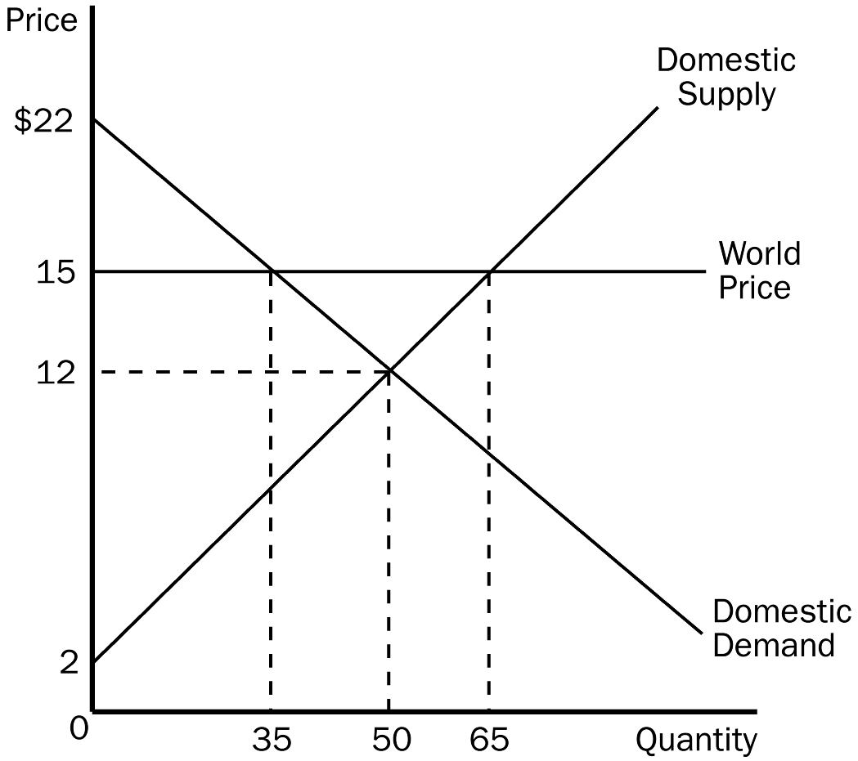
a. What is the equilibrium price of CDs before trade?
b. What is the equilibrium quantity of CDs before trade?
c. What is the price of CDs after trade is allowed?
d. What is the quantity of CDs exported after trade is allowed?
e. What is the amount of consumer surplus before trade?
f. What is the amount of consumer surplus after trade?
g. What is the amount of producer surplus before trade?
h. What is the amount of producer surplus after trade?
i. What is the amount of total surplus before trade?
j. What is the amount of total surplus after trade?
k. What is the change in total surplus because of trade?
ANS:
a. $12
b. 50
c. $15
d. 30
e. $250
f. $122.50
g. $250
h. $422.50
i. $500
j. $545
k. $45
PTS: 1 DIF: 2 REF: 9-2
TOP: Exports | Economic welfare MSC: Applicative
2. Using the graph below, answer the following questions about hammers.
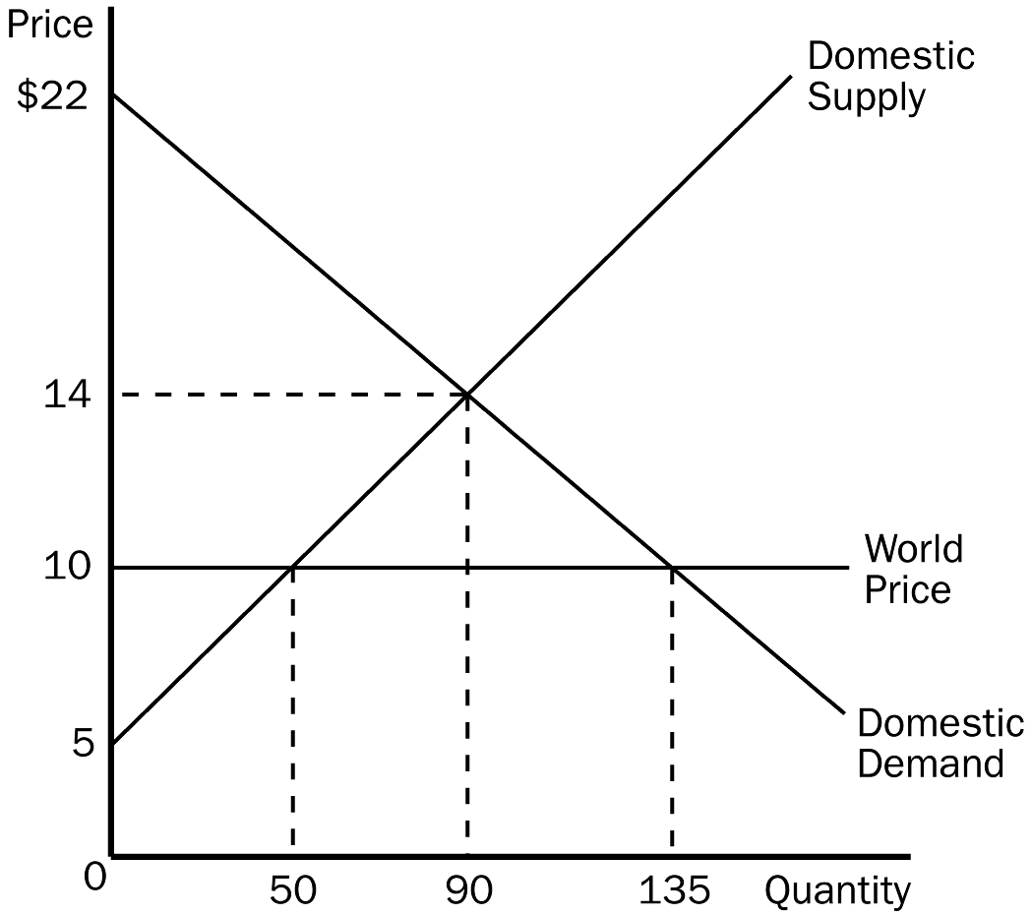
a. What is the equilibrium price of hammers before trade?
b. What is the equilibrium quantity of hammers before trade?
c. What is the price of hammers after trade is allowed?
d. What is the quantity of hammers imported after trade is allowed?
e. What is the amount of consumer surplus before trade?
f. What is the amount of consumer surplus after trade?
g. What is the amount of producer surplus before trade?
h. What is the amount of producer surplus after trade?
i. What is the amount of total surplus before trade?
j. What is the amount of total surplus after trade?
k. What is the change in total surplus because of trade?
ANS:
a. $14
b. 90
c. $10
d. 85
e. $360
f. $810
g. $405
h. $125
i. $765
j. $935
k. $170
PTS: 1 DIF: 2 REF: 9-2
TOP: Imports | Economic welfare MSC: Applicative
3. Using the graph, assume that the government imposes a $1 tariff on hammers. Answer the following questions given this information.
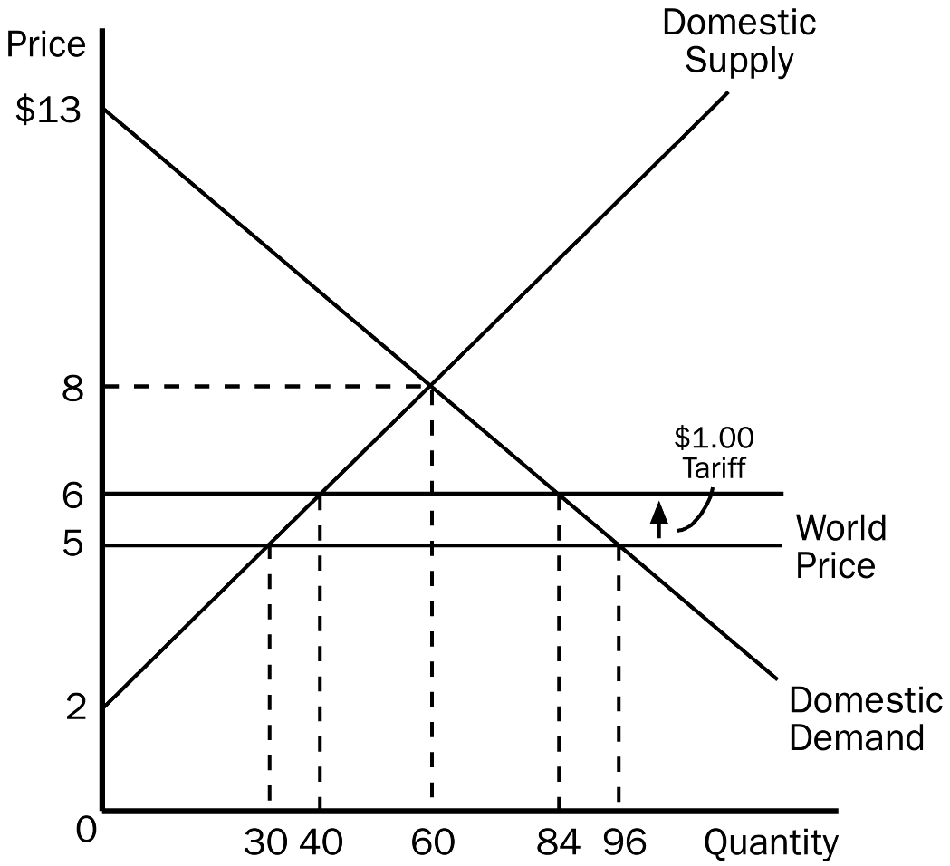
a. What is the domestic price and quantity demanded of hammers after the tariff is imposed?
b. What is the quantity of hammers imported before the tariff?
c. What is the quantity of hammers imported after the tariff?
d. What would be the amount of consumer surplus before the tariff?
e. What would be the amount of consumer surplus after the tariff?
f. What would be the amount of producer surplus before the tariff?
g. What would be the amount of producer surplus after the tariff?
h. What would be the amount of government revenue because of the tariff?
i. What would be the total amount of deadweight loss due to the tariff?
ANS:
a. $6, 84
b. 66
c. 44
d. $384
e. $294
f. $45
g. $80
h. $44
i. $11
PTS: 1 DIF: 2 REF: 9-2
TOP: Tariffs | Economic welfare MSC: Applicative
4. How does an import quota differ from an equivalent tariff?
ANS:
Both the import quota and the tariff raise the domestic price of the good, reduce the welfare of domestic consumers, increase the welfare of domestic producers, and cause deadweight losses. The only difference for the economy is that the tariff raises revenue for the government, while the import quota creates surplus for license holders.
PTS: 1 DIF: 2 REF: 9-2
TOP: Tariffs | Import quotas MSC: Interpretive
5. Characterize the two different approaches a nation can take to achieve free trade. Does one approach have an advantage over the other?
ANS:
A unilateral approach is when a country removes its trade restrictions on its own. A multilateral approach is when a country removes its trade restrictions while other countries do the same. A multilateral approach has two advantages. The first is that it has the potential to result in freer trade because it can reduce trade restrictions abroad as well as at home. If international negotiations fail, however, the result could be more restricted trade than under a unilateral approach. Also, the multilateral approach may have a political advantage and can sometimes win political support when a unilateral reduction cannot.
PTS: 1 DIF: 2 REF: 9-3
TOP: Trade policy MSC: Interpretive
6. What are the arguments in favor of trade restrictions, and what are the counterarguments? According to most economists, do any of these arguments really justify trade restrictions? Explain.
ANS:
Arguments mentioned in the text include the jobs argument, the national security argument, the infant industry argument, the unfair competition argument, and the protection-as-a-bargaining-chip argument. These arguments and counter-arguments are outlined in section 9-3 of the text. Most economists would dismiss the jobs argument, the infant industry argument, and the unfair competition argument on strictly economic grounds. The bargaining-chip argument carries high risks of economic harm if the threat doesn't work. The national-security argument balances economic loss from trade restriction against the benefit of long-term national survival, and is probably the argument that economists would most likely buy if it were clear that the industry being protected was clearly crucial to national security.
PTS: 1 DIF: 2 REF: 9-3
TOP: Trade policy MSC: Interpretive

